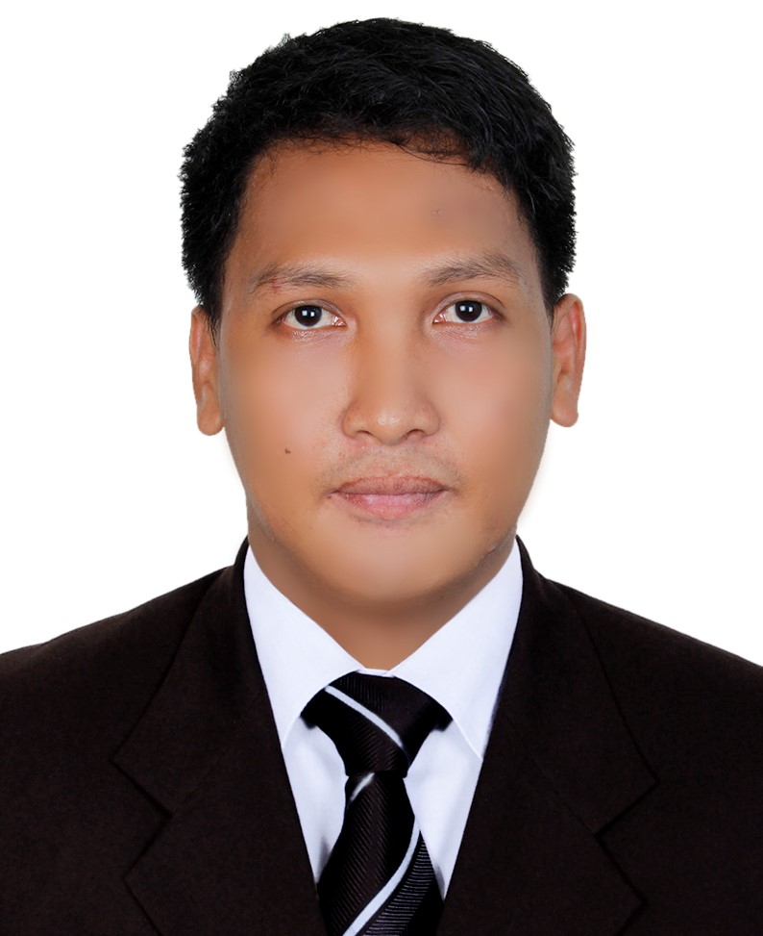

PERSONAL DATA

AGE : 26 years’ old
DATE OF BIRTH : Feb.21, 1990
VISA STATUS : Visit Visa
NATIONALITY : Filipino
CIVIL STATUS : Single
RELIGION : Roman Catholic
LANGUAGES SPOKEN : Filipino, English

EDUCATIONAL BACKGROUND

Panpacific University North Philippines
Bachelor of Science in Electronics and Communications Engineering
2007-2012
ON-THE-JOB TRAINING

Field Engineering Intern
SKY CABLE INC.,
Urdaneta City,Philippines

- Assist engineers/technicians in installation, disconnection, maintenance and troubleshoot of subscriber’s line.
- Maintain/ensure the quality of signal to meet the customer expectations.

SKILLS

- In-depth knowledge of the principles and terminologies of Electronics and Communications System.
- Good communication and writing skills.
- Good in problem solving.
- Able to read electrical wirings and circuit diagram.
- Knowledgeable in circuit designing and PCB fabrication
- Resourceful, organized, self-motivated, positive and has iniative to learn in other aspects of engineering industry.
- Knowledge in Microsoft Office (Word, Excel and PowerPoint).
- Fast learner.

Ludivico
Ludivico.316824@2freemail.com

CAREER OBJECTIVE

To obtain a challenging position in high quality of engineering environment where my resourceful experience and academic skills will add value to organizational operations.

SUMMARY OF QUALIFICATIONS

- Working as Equipment Engineer in more than 3 years of experience in industry.
- Good experience in Lead/Supervise for the Equipment section in the Equipment Department.
- Good in descision-making skills.
- Can work under minimum supervision with strong leadership and analytical skills.

SEMINARS ATTENDED

“4TH GENERATION (4G)” 01/ 29l2012 Resource Speaker: Engr. Jaime C. Tiong Jr.
IECEP-CARSC Regional Seminar
University of the Cordilleras Baguio City Philippines

WORK EXPERIENCE

Associate Engineer (Team Leader) 05/2013 – 03/2014
Optis Smart Manufacturing Philippines Inc. Cavite, Philippines

- Responsible for maintaining and repairing equipment required in the day to day working.
- Utilized different reliability and testing strategies in production to maintain and improve operation’s profitability.
- Performed routine maintenance inspections of equipment to identify and respond to problems in a timely manner, thus preventing breakdowns.
- Set-up, calibrate and maintain test equipment.
- Making needed Technical Reports to use as reference.

Engineer II (Shift Leader) 03/2014 – 08/2016
Optis Smart Manufacturing Philippines Inc. Cavite, Philippines

- Lead and supervised members on their daily job.
- Making reports for suggestions and recommendations.
- Responsible in resolving issues of customer complaints.
- Assigned employee on their expertise area.
- Monitoring all members to be performed their duties and responsibilities of their respective area.
- Monitoring and continuously working on cost effective & maintenance free solutions for all types of electronic components used in our existing & in new under developed machines.

