CURRICULUM VITAE
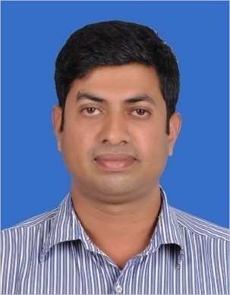
JOSEPH E-Mail: joseph.316833@2freemail.com
Civil Engineer
Site Engineer with 9 years of experience in the field of commercial and Residential construction project. History of finishing projects in time and in budget through successful planning and coordination. Continuously strive hard to produce quality work during tight schedule and limited budget. Effective written communication through document preparation for follow up and approval. Effective implementation of Policies and rule for the projects for quality and output.
Professional Experience
Al Ali Engineering Co. W. L.L Doha, Qatar
Billing Engineer July, 2013 to July, 2015
Managing all aspect of Billing works including Preparation of BOQ, monthly IPC, Subcontractor Bills, Work Breakdown Structure, Work Inspection Requests etc. for the Heritage Projects in Al Khor & Al Dhakhira.
Arabic Carthage Trad & Cont L.L.C Muscat, Oman
Project Engineer June, 2010 to Dec, 2012
Managing all aspect of project including Material management, Labour management, Documentation & Control, Attending meeting with client & consultant, Implementation of policies for project, Quantity estimation, Scheduling of projects.
Key Projects Carried out
- Construction of Residential Villa for Ahmed Ibrahim Al Maimini, Mabella
- Construction of Defence Training Course, Muscat
- Construction of Villas for Ministry of Housing, Sohar

Orient Constructions Changanacherry Kerala, India
Site Engineer May, 1996 to Sept, 2005
Organize and manage the site. Responsibilities include study of drawings and execute the work as per drawings, managing the labour force present in the site.

Key Projects Carried out
- Construction of ICSE block for K.E.School Mannanam
- Construction of Adoration Convent Athirampuzha
- Construction of Chapel for K.E.College Mannanam
- Construction of St. Joseph’s Med. College Mannanam
- Construction of Priest Home Chethippuzha
Language Skills
- Read: English, Hindi, Malayalam
- Write: English, Hindi, Malayalam
- Speak: English, Hindi, Malayalam

Academic Credentials:
Examination  Passed. | Board/University | Institution. | Percentage
BE, (2005-2009)  Civil | VTU, Belgaum | Sri. Venkateshvara college of engineering, Bangalore | 72.5%
Diploma, (1993-1996)  Civil | Dept. of Technical Education, Kerala | Govt. Polytechnic, Kottayam | 65.5%
S.S.L.C, (1993) | Govt: of Kerala | Emmanuel’s. H. S, Kothanalloor, Kottayam | 78%

Software Proficiency
Staad Pro
Auto Cad
Primavera 6
Office 2007 : Excel Calculation, Presentation, Documentation

Personal Detail
Date of Birth : 16/12/1977 Age: 38 Sex: Male

Declaration
I hereby assure that all the above details are true to my knowledge and I will work with full dedication and sincerity to bring prosperity for your Concern.

Mr JOSEPH
Kottayam,
10-10-2016.

