SHAFEEQ
Civil Engineer
Mail:shafeeq.317248@2freemail.com
Visa Status : Visiting Visa

CAREER SUMMARY
An enthusiastic and highly motivated individual who has a clear understanding of the role and responsibilities associated with being a Civil Engineer. Physically fit and able to work on-site and at remote locations. I am more than willing to undertake any work of a technical nature that falls within his ability and competence and I possesses a broad range of technical, personal effectiveness and leadership skills and uses rigorous logic and methods to come up with effective solutions to difficult problems. I am currently looking for a suitable position with a ambitious company where he will be working with industry experts, people who have the skills and experience to make a real difference to his future.

PROFESSIONAL QUALIFICATIONS
- Bachelor's Degree in Civil Engineering - Calicut University , Kerala , India

PROJECT HANDLED
- GREEN BUILDING FOR QUALITY LIVING

The Scope of the project lies in the planning of Green Building in accordance with IGBC and designing various techniques such as rain water harvesting system, bio gas plant, solar photovoltaic system etc. that makes the green building energy efficient.

Main objectives of the project are.

- Planning of Green villa project with 6 villa using IGBC features

- Study of locally available & rapidly renewable materials

- Detailed study of IGBC home rating system v2.0 and analyzing

- Designed various energy efficient techniques

ACHIEVEMENTS
- Participated in a one day Workshop on ‘Fundamental of construction Management & Setting out of Building Plan’ conducted by Department of Civil Engineering, RCET .
- Paper presentation on ‘Green Building For Quality Living’ in the National Conference on Emerging Technologies(NACET 2K16).
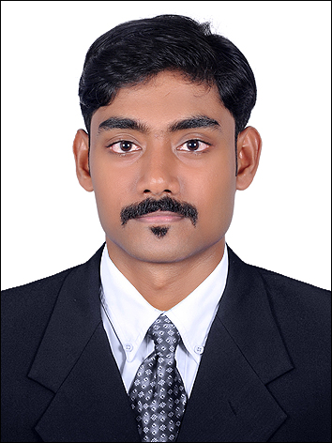

AREAS OF EXPERTISE
  - Site Inspections
  - Infrastructure projects
  - Health & safety Private
  - House building
  - Large scale commercial buildings
  - Public sector buildings
  - Rail projects
  - Bridges
  - Project management

TECHNICAL SKILLS
- Familiar with relevant Civil Engineering design
software like Stadd Pro.
- Moderate ability with AutoCAD.
- Computer literate and conversant with
MS Office suite and relevant engineering software packages.

PERSONAL SKILLS
- Self­motivated, precise and dedicated.
- Ability to achieve short term and long term objectives.
- Ability to handle multiple tasks and work under pressure.
- Ability to understand and present others' points of view.
- Good communication skills when dealing with clients, developers, consultants,elected representatives and the public.
- Keeping up to date with industry best practice.

PERSONAL PROFILE
  - Date of birth : 14 September 1992
  - Marital status : Single
  - Nationality : Indian
  - Languages: English, Hindi & Malayalam

