Mahmoud
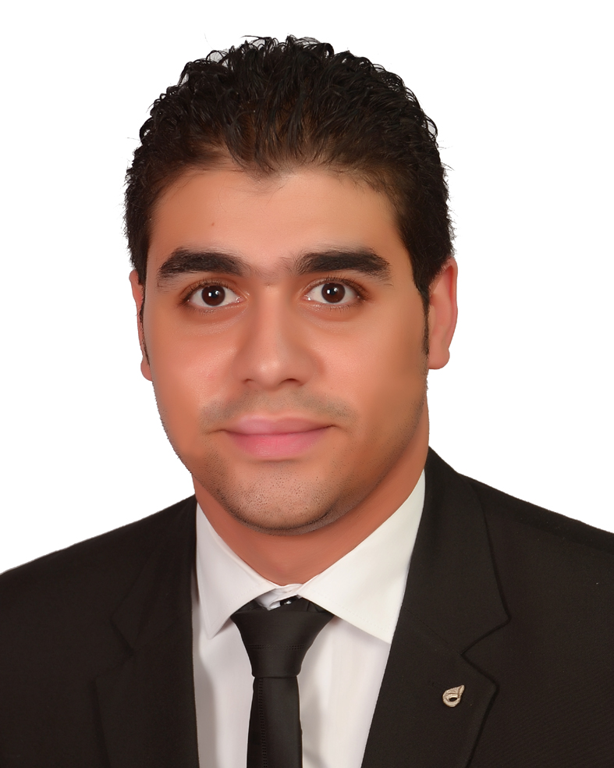
Mahmoud.317363@2freemail.com

Education
- High school (2006): From Egypt (Tabry elhgaz secondary school)
- University (2011): From Egypt (Canadian International College)
- Department: Network
- Graduation project: Excellent
- Project Brief: ● B.M.W Sales and Maintenance system for staff
● B.M.W Website reservation for customer

Work Experience

Egyptian Life Takaful May 2014 current.

- Senior Technical Support Engineer:
- Deployment and configuring of Microsoft windows (Servers [2008, 2012]and client [7 & 8])
- PC hardware (understanding, installation, configuration, repair if possible)
- Network (installation HW; configuration; permission, routers configuration)
- Microsoft Office.
- Microsoft Exchange (Create, change, and delete user accounts per request.)
- Symantec Antivirus
- GFI End Point Security
- AVAYA Site Administrator
- Backup exec
- MS LYNC Server
- SCCM
- ManageEngine ServiceDesk Plus Administrator (Ticketing System)
- Printer Server
- End User Support
- Attendance Project

Al Zawak Company (April 2014).
- System administrator assistant:
- H/W
- Remote Connection
- Recruitment
- Sales & Marketing

Saudi Arabian Airlines May 2009-Dec 2011

- Traffic control:
- responsible for loading and unloading Cargo
- Load balance for aircraft
- Check the boarding

Key Projects
- WDS: Windows Deployment Service Deploy Windows remotely throw network

Certifications

- IELTS

Technical Skills

- Deployment and configuring of Microsoft windows (Servers [2008, 2012]
and client [7 & 8])
- PC hardware (understanding, installation, configuration, repair if possible)
- Network (installation HW; configuration; permission, routers configuration)
- Microsoft Office.
- Microsoft Exchange (Create, change, and delete user accounts per request.)
- Symantec Antivirus
- GFI End Point Security
- AVAYA Site Administrator
- Backup exec

Training Courses

- CCNA Course
- IELTS
- MCSA
- ITIL

PERSONAL INFORMATION
- Date of Birth : Dec 03th, 1989
- Marital Status : Single
- Nationality : Egyptian
- Military state : Completed

