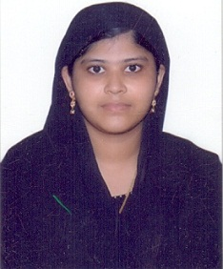
MUBSIRA
Email: mubsira.317702@2freemail.com
Objective
Seeking a suitable position in any department where I can utilize my technical as well as intellectual abilities to contribute to the company's operations.

Qualification
Degree/Examination | Name of the Institution | Board/University | Year of completion | Percentage
M.Sc. Computer Science | MIET Arts & Science College, Trichy, India | Bharathidasan University, Trichy, India | April 2016 | 84%
B.Sc. Computer Science | Meenakshi Chandrasekaran College, Tanjore, India | Bharathidasan University, Trichy, India | April 2014 | 86% (University Rank Holder)
Higher Secondary | Khadir Mohideen H.S.S., Adirampattinam, India | State Board | April 2011 | 76%
Secondary | Khadir Mohideen H.S.S., Adirampattinam, India | State Board | April 2009 | 88%

Technical Skillset:
Language : C, C# .Net, VB.Net, ASP.Net.
Database : MS-SQL Server 2005, MS-Access, MySQL.
Web Page Development : HTML, PHP
Graphic Designing : Adobe Photoshop

Extra-Curricular
- Presented a paper on Wireless Sensors at National conference (NACOFACT 2015), Trichy, India.
- Hosted quiz for inter-school competitions.
- Won prizes in speech competitions.

Professional Strengths
- Strong analysis, development and implementation skills.
- Excellent communication and written skills.
- Good time management and project management skills.
- Good knowledge of computers and gathering of information from the internet.
- Perseverance, Honest, Diligent, ability to learn quickly with adequate training.

Languages
English, Tamil and Hindi - Proficient
Arabic - Intermediate

Personal Information
Gender - Female
Date of Birth - 26th July 1992
Marital Status - Unmarried
Nationality - Indian
Religion - Muslim

Other Interests
Henna designing, Drawing & painting, Cooking, Gardening.

Passport Details

Passport No. & Validity - 28th May 2023
Visa Status - Visit visa valid till April 7th 2017
References
Will be provided upon request.

