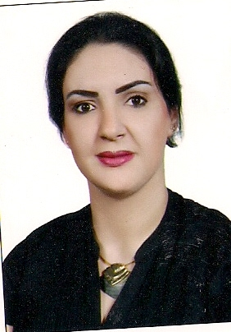
Curriculum Vitae

Name: Rebai
E-mail: rebai.317724@2freemail.com

Personal information
Birthday: 5/11/1979
Place of birth: Tunis, Tunisia
Nationality: Tunisian
Gender: female
Marital status: single

OBJECTIVES:
To obtain a position in a company that will provide opportunities both for my personal and professional growth

Education
June 2007, Amideast, Tunisia
Certificate of Achievement in Test of English for International Communication (TOEIC)

November 2006 – May 2007, (CREFOC,Ariana-Tunisie)
Certificate in Business English

February 2004, the African Bank of Development, Tunisia
Training in the human resources department.

2004, Institut de Travail et des Etudes Sociales, Tunisie.
B.A in Human Resources (sciences de travail)
2000, High school Hannibal, Ariana , Tunisia
Baccalaureate of Arts certificate

SKILLS:

• Good interpersonal skills, displaying confidence in achieving and maintaining professional credibility
• Forward thinker who works well on own initiative and passion.
• Have the ability to manage time efficiently
• Fast learner
• Computer Literate

Experience:

June 2012 – till now
Secretary in Etijahat Business Development
• Responsible for providing administrative support to the administrative manager and managing other tasks as assigned by the manager
• Responsible for attending meeting with the manager and assisting in creating new policies and plans to the company’s objectives
• Responsible to preserve relationship with clients to understand their requirements
.filing, archiving, scanning and faxing documents
. Answering and dealing with incoming and out coming telephone calls

March2011- April 2012 (Tunisia)
Medical secretary in Tunisia:
. Responsible for answering the phone
. Interacting with patients
. Taking appointments
.responsible for all the office work

March 2010- february2011
Administrative assistant in an importing company in Tripoli Libya (Elentissar Company for importing trucks and spare parts- IVECO)
- Translate documents (emails, letters, faxes,) from french to Arabic and vice versa
- Responsible for customer’s reception
- In charge of the document control department, controlling the flow of documents.
- Scanning of incoming/outgoing documents and arranging them accordingly for easy retrieval and reference.
- Looking after the day to day works for the maintenance of the office document, log register, and receiving calls.
- Follow up on inquiries and other related works.
- Assisting my manager in meetings and preparing reports after meetings.

May2008-February 2010 to present, Medical secretary of a paediatrician and a dermatologist (Tunisia)
. Responsible for answering the phone
. Interacting with patients
. Taking appointments
. Sterilizing medical equipment
. Preparing the diagnostic room for patient care.
.responsible for all the office work

2006-January 2008(Tunisia)
Private tutor (French & Arabic course)

September 2004 - December 2006, secretary in cleaning service company (Elwafa services Tunisia)
. Responsible for coordination between customers and Labour
. Ensuring high quality service
.answering the phones, making appointment with client

Other information
Fluent in Arabic: written and spoken
Fluent in French: written and spoken
Fluent English: written and spoken
Computer skills: Word processing, Excel, PowerPoint and Internet skills

Interests
Reading, exercise, music and cooking

