CURRICULUM VITAE

NAME | : WURAOLA | 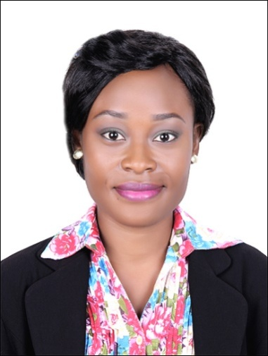
DATE OF BIRTH | : 13 February 1986
MARITAL STATUS | : Single
VISA STATUS | : 3 MONTHS TOURIST VISA
C/o-MOBILE | : +971 502360357
EMAIL | : wuroaola.317923@2freemail.com
OBJECTIVE
- Seeking a challenging career with a distinctive organization having an operation that provides a meditative work environment as well as an opportunity for career advancement in order to enhance, broaden and utilize my qualification and acquired experience.

WORK EXPERIENCE:
JUSTDAY INTERNATIONAL SECONDARY SCHOOL, Lagos, Nigeria.
September 2014 – Present

POSITION –ENGLISH& CREATIVE ART TEACHER
Responsible for making a positive and regular contribution to the school’s extra-curricular and enrichment program, leading, coaching and supporting students to develop their academic skills as well as their creative ability.

Duties:
- Planning and preparing appropriate lessons and suitable teaching materials.
- Teaching within the designated subject areas.
- Working in accordance with the school’s curriculum statement and policies.
- Monitoring and assessing students’ progress.
- Participating in the development of appropriate syllabuses, material and schemes of work.
- Carrying out a share of supervisory duties.

MATEM PRIVATE SCHOOL, Lagos Nigeria.
May 2009- January 2010

POSITION – ENGLISH & VERBAL REASONING TEACHER
Responsible for assisting in the educational and social development of pupils under the direction and guidance of the head teacher

Duties:
- Prepared lessons independently for ten weeks based on the National curriculum.
- Actively involved in curriculum review and development.
- Worked one on one with pupils that have a variety of special needs.
- Continuously taught, reflected, and modified skills by providing pupils with assignments and assessments.
- Played an active role during parent-teacher conferences.

EDUCATION:
- UNIVERSITY OF IBADAN, OYO STATE, NIGERIA. 2015
- OGUN STATE UNIVERSITY, AGO-IWOYE, NIGERIA. 2006
- IJAMIDO INTERNATIONAL COLLEGE, OTA, NIGERIA. 2002

ACADEMIC QUALIFICATION:
- B.A (PHILOSOPHY AND PUBLIC AFFAIRS). 2015
- DIPLOMA IN INDUSTRIAL AND LABOUR RELATIONS. 2006
- WEST AFRICAN SCHOOL LEAVING CERTICATE. 2002
- NATIONAL EXAMINATION COUNCIL, NECO. 2002
INTEREST & HOBBIES
- Drawing and painting
- Traveling
- Making friends
- Reading

STRENGTHS AND ABILITIES
- Good analytical, writing and communication skills.
- Proficiency in Microsoft Word.
- Open to new ideas, methods and approaches and embracing change initiatives.
- Values others input and expertise and is willing to learn from others.
- Ability to multi-task at various challenging roles.
- Ability to initiate professional ideas, implement strategic policies and ensure compliance.

REFERENCES: AVAILABLE ON REQUEST

