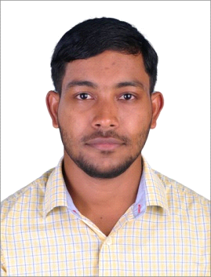 | ABDUL  ABDUL.318004@2freemail.com
Objective: | • I aim to seek full time employment in a School/college/  university whe re I can use my teaching qualifications and experience to enhance students’ learning. I am a very competent teacher who will make a worthwhile and valuable contribution to any institution in which I am employed.
Capabilities: | - A talented teacher who can instruct the Arabic language, history, hotelier as well as translation.  - Good command over verbal and written Arabic as well as command of English  - Excellent interpersonal skills and have basic knowledge in Computers.  - Rapid adaptability to new problem-solving and new locations.
Acadamic: | - MA in Arabic . EFL University, hyderabad .(2014-2016)  - BA in Arabic .University of calicut .(2011-2014)  - Higher Secondary School Certificate + 2 (Humanities) NIOS ,(2010)  - High School Certificate Exam. 10th Std. AMHSS, Thirurkad (2006-2007)  - NET in Arabic (2015)  - Kerala arabic teachers examination (2013)  - Bachelors in Shareea , Al jamia Al islamiya Santhapuram  - Diploma in Translation , EFL university, hyderabad
Hobies and Intersts: | • Read Arabic and English books  • Arabic translation of pieces of sheets into English and vice versa  • Writing literary articles in Arabic and English  • Listen to Betrothments in both languages
Languages writing, reading and conversation: | • Arabic  • English  • Urdu  • Malayalam

Declaration:

I hereby declare that the above particulars are true and correct to the best of my knowledge and belief and in the event of any information being found false or incorrect, my candidature will be liable to be canceled.

