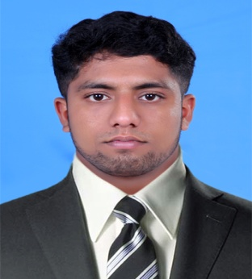  Personal Data:  Date of Birth:  - 31-01-1991  Gender:  - Male  Nationality :  - Indian  Languages Known:  - English,Malyalam,Kannada,  Tamil. | Curriculum vitae  JIJO  JIJO.318426@2freemail.com  Objective  To secure a respectable position in the company to do the best of my ability and exercise skills that already obtained and maintain the true value of hospitality for satisfaction of the management and the great customer’s. Multitalented individual with my sincerity and dedications approach towards the goal.  Academic Qualification  - 2006–2008-(PLUS TWO): Vijaya H.S.S Pulpally  - 2005–2006-(10): JAYASREE H.S.S KALLUVAYAL  Professional Qualification  - 2008-2013: Completed 5 Year Master Degree In Master of Tourism Administration from SBRR Mahajana First Grade College Mysore,Karnataka,India  Percentage of marks  - PLUS TWO 60%  - SSLC 62%  Summary of qualification  - Has extensive exposure in Hospitality & Travel operation  - Possesses strong interpersonal skills and effective communication  - Multy skilled individual, computer literate and can work under extreme pressure  Job Experience  - Completed industrial training from The ZURI KUMARAKAM  - Worked in CRAZY HOLIDAYS (Senior Executive, Handling inbound Operations& Sales Bangalore(June2014-June2016)  - Currently working with ORCHID RESORTS & SPA , as Reservation/ front office Manager  Duties and responsibilities  Crazy Holidays Bangalore  - Liaising with clients in person, over the phone or via email to discuss their travel requirements.  - Advising clients on suitable options for domestic or  international destinations, tours, accommodation, transport, insurance and fares.  - Preparing customised itineraries to suit the clients’  preferences and budget.  - Modifying existing bookings to suit a change in clients’  circumstances.  - Researching destinations and keeping up to date with  travel industry news.  - Ongoing training with other team members and  management  ORCHID RESORT & SPA,Wayanad  - Reporting to General manager  - Responsible for cashiering works  - Responsible for the daily Front office operation  - Checking the guest satisfactions  - Conducting training for the staff  - Review arrival report daily  - Supervising of Group Reservations.  - Responsible for preparation of occupancy forecast  - Responsible for Company/Travel agent Rates both in system and correspondence file  - Liase with sales department in regards to occupancy, Rates reservation analysis.  - Review no-show and cancelled reservations and processes charges according to hotel policy  - Ensure special handling of repeats guest and VIP guest.  - Responsible for maintaining a neat and orderly position at all times.  Training/seminars  - Customer service  - Personality development  - Travelled all over Indian tourism destination  Declaration  I hereby certify that the above mentioned details are true and correct for the best of my knowledge.

