Email: amir.318641@2freemail.com

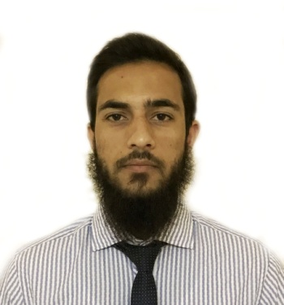

Professional Profile

Civil Engineer with more than 1 yrs of vast experience in infrastructure like, Roads, Bridges, High rise buildings, Piling, Long span bridges and Industrial Buildings etc. Superstructures and Substructures detailed design. Experience in site supervision, construction works.

Career Objective

A well motivated, committed & conscientious Civil Engineer seeks an opportunity in an organization with a proven expertise in providing optimal solutions to the dynamic needs of the organization, where I cannot only utilize my skills, experience & abilities but also help the organization to identify its need and professional growth. To understand and to identify the needs & co-relate them with my goals so that I can apply myself with total devotion, dedication, & dynamism.

Technical Skills

AutoCAD 2D and 3D.
MS-Office, Windows 7, Windows 8, Windows 10.

Professional Experience

Position Site Engineer at Construction of water Treatment plant of capacity 10 MGD at “Tangnar” Sponsored under Scheme “Jawahar Lal Nehru Urban Renewal Mission”.

Project: Construction of Water Treatment Plant
Consultant : R&B government department through Z&Z Govt. Contractors and general Suppliers.
Position held: Site Engineer (May 2015 – Oct 2016).

Key Responsibilities Handled

- Controlling and assigning the manpower according the work requirements.
- Supervising the work to check it in accordance with the technical specifications.
- Proper utilization of equipments in operation.
- Conduction of different tests required for concrete and steel.
- Supervising the backfilling of underground floor.
- Reviewing and studying the plans, profiles and checking whether the work is executed in accordance with that.
- Preparation of daily and monthly Report.
- Organizing the work in such a manner to extract maximum production out the manpower and equipments involved.

Academic Qualification

Senior Secondary 2008 from Green Valley Educational.
Higher Secondary 2010 from S.P high secondary school.
B.Tech (CIVIL ENGINEERING) 2015 from Lovely Professional University.

Academic Projects undertaken

- 6 weeks Industrial training in construction of test pile of 20m depth at Gani memorial Stadium.
- Construction of community hall.
- Stabilization of soil with cement and lime.

Personal Details

Name : Aamir
Language known : English, Urdu, Hindi
Nationality : Indian
Date of Birth : 02-01-1991
Status : Single
Reference on request.

Declaration

I am confident of my ability to work in a team. I hereby declare that the information furnished above is true to the best of my knowledge.

Aamir

