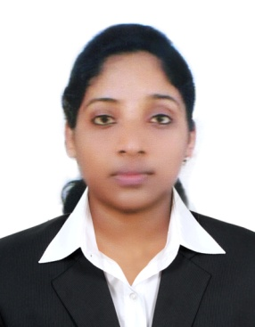 Niroshini
Niroshini.318727@2freemail.com
Sr. Medical Transcriptionist

OBJECTIVES
To work with a team of highly motivated and professional members that will provide me an insight into the practical application of my knowledge and skills, seek a challenging position to commensurate with my qualification in career growing organization. I want a highly rewarding career where I can use my skills and knowledge to help the company and my coworkers be successful.

SKILLS
- Expert in Ms Office
- Excellent typing speed
- Medical Terminology
- Ability to work under pressure
- Decision making
- Time management
- Leadership
- Teamwork

WORK EXPERIENCE
Worked as a senior medical transcriptionist for five years at MedSource Pvt.Ltd.(Sri Lanka) since 2010 to 2015.

ACADEMIC QUALIFICATIONS
G.C.E. Advanced Level Examination in 2009 (Government)
G.C.E. Ordinary Level Examination in 2005 (Government)

OTHER QUALIFICATIONS
⦁ Having attended a course of lectures and demonstration in Basic First Aid (Sri Lanka Red Cross Society 2004).
⦁ Completed a 4 months course titled English For Life at Gateway English Language Centre (2009).
⦁ Participation in the Training program on Personal Development & Leadership (2009).
⦁ Advanced Training in Medical Transcription (2010).
⦁ Best Teamwork (2011-2012) at MedSource Pvt.Ltd.
⦁ Has attended a Spoken English Course at British Council, Sri Lanka (2015).

PERSONAL DETAILS
Date of Birth: 01st of January 1990.

Marital Status: Married.

Language Known: English, Sinhala, and Tamil.

Gender: Female.

Nationality: Sri Lankan.

Visa Status: Visit Visa

Date of Issue: 31st of January

Date of Expiry: 29th of April

I do hereby certify that the particulars furnished by me in the application, are true and accurate to best of my knowledge and if selected, I shall perform my duties efficiently, loyally and to your entire satisfaction.

