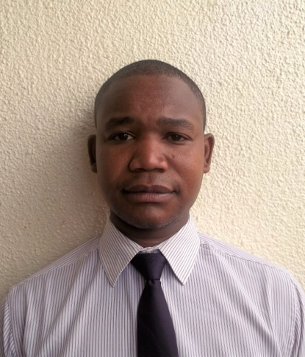RESUMÉ
for
ADMIRE

Admire.318849@2freemail.com

Career Objective: Seeking a responsible and challenging position in the Sales and Marketing department which allows for the application of my skills and expertise in Sales, Marketing, Customer care, Receiving and Merchandising.
EDUCATIONAL BACKGROUND
The British College of Professional Management

January 2007- December 2007.

TOURISM& TRAVEL AGENCY MANAGEMENT

- Diploma
COMPUTER SKILLS:

- Technical: Microsoft (Office, Word, Excel, PowerPoint).

WORK EXPERIENCE:

1: SALES EXECUTIVE
EDGARS GROUP OF STORES (Zimbabwe)

January 2014 to February 2016
Performance Area
• Ensure high levels of customer satisfaction through excellent sales service
• Maintain outstanding store condition and visual merchandising standards
• Maintain a fully stocked store
• Ascertain customers' needs and wants
• Recommend and display items that match customer needs
• Welcome and greet customers
• Manage point-of-sale processes
• Actively involved in the receiving of new shipments
• Keep up to date with product information
• Accurately describe product features and benefits
• Follow all company policies and procedures

2:Group Reservationist
Rainbow Tourism Group, Harare, Zimbabwe
March 2008 – December 2013

Provided outstanding first impression of Rainbow towers hotel and conference centre through professional presentation of information to potential guests concerning rates, availability of rooms, description of facilities and services and information about area attractions. I am hardworking, confident, reliable and efficient marketing and sales person. I worked for Rainbow Tourism Group as a group Reservationist marketing and selling its all 12 hotels and lodges throughout the country (Zimbabwe) that includes their five star hotel Rainbow towers and conference centre in Harare.

Duties
- Promptly answered reservation inquiries via telephone, fax, voicemail and/or email in a friendly and professional manner
- Analyzed data to determine availability and rates
- Entered reservations into the property management system both completely and accurately
- Utilized proper selling techniques and strategies to maximize budgeted room occupancy and ancillary revenue goals
- Produced and sent letters of confirmation and other well-written correspondence
- Obtained and transmitted accurate information for each reservation
- Gave detailed information as needed to callers regarding rates, packages and all aspects of the resort
Key competences
- Able to work as part of a team
- Good communication skills
- Comfortable working with members of the public
- Friendly and engaging personality
- Persuasiveness
- Patient
- Mannered
personal profile:
Date of Birth : 04/01/88
Gender Male
Marital Status : Single
Nationality : Zimbabwean
Languages : English
)

