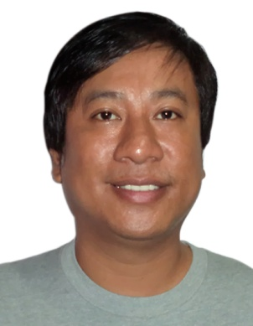
OGIE
EMAIL: ogie.318932@2freemail.com

CAREER OBJECTIVE

To build career in a growing organization, where I can get the opportunities to prove my abilities by accepting challenges, fulfilling the organizational goal and climb the career ladder through continuous learning and commitment.

EDUCATION

1998-2003
Bachelor of Science in Civil Engineering - Graduate
University of Luzon,Dagupan City Philippines

WORK EXPERIENCE

May 2012 – August 2016
SUPERVISOR ENGINEER
- Supervising in Constructing two – Storey Residential Houses

Company: Julius Calano Construction
Address: San Fabian Pangasinan, Philippines

December 2008 – March 2012
SURVEY ENGINEER
- Survey of Construction Road and Bridges
- Riprap and Side Slope
- Leveling Cut and Fill

Company: CM Pancho Builders
Address: Kamuning Quezon City, Philippines
SKILLS
  - Internet
  - Microsoft Word
  - Power Point
  - Microsoft Excel
TRAININGS ATTENDED
April- May 2008 - On the Job Training
Dagupan City Engineers Office
Dagupan City,Philippines
PERSONAL PARTICULARS:
Age :35 years
Date of Birth : 10 Oct. 1981
Gender : Male
Civil Status : Married
Height : 5 ft. 6 inches
Weight : 75 kls.
Nationality : Filipino
Religion : Christianity- Catholic

I solemnly declare that all the above information is true and correct to the best of my knowledge and belief.
________________________
Applicant’s Signature

