RESUME
NOBLE.318963@2freemail.com 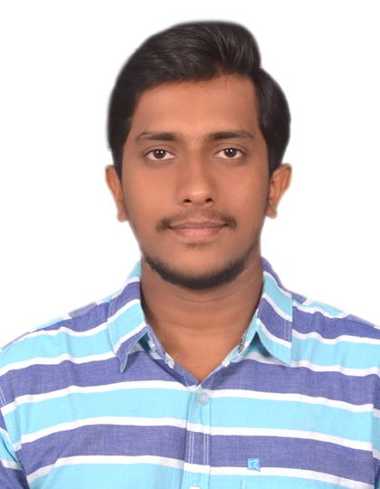
NOBLE

Objective :

To work in a globally competitive environment on challenging assignments that shall yield the twin benefits of job satisfaction and a steady-paced professional growth. I strive to use my Technical skills for improving profit of an organization. In addition, I am eager to contribute my creativity and hard work towards the success of the company.

Experience Summary:
- Worked as QC Supervisor (Piping) for one year and seven months under Larsen and Toubro Ltd for J3 Project . Reliance Industries Ltd, Jamnagar, Gujarat.
Educational Summary:
- B.E Mechanical Engineering from Rao Bahadur Y Mahabaleswarappa Engineering College, Bellary, Affiliated to Visveswaraya Technological University, Belgaum.

Computer skills:
Operating systems : Windows 8 & 10.
Computer Skills : MS Office, MS Excel.

Educational qualification:
Degree : Bachelor of Engineering (Mechanical).
University : Visveswaraya Technological University, Belgaum, Karnataka.
PUC : Smiore Vyasapuri composite Pre University College, Hospet, Karnataka.
SSLC : St Joseph’s school TB Dam, Hospet, Karnataka.

Additional certification:
- CSWIP 3.1 (WELDING INSPECTION LEVEL II ).
- QUALITY CONTROL ASNT Level II in:-RT, UT, MT, PT.
- PROCESS PIPING AND DESIGN AS PER ASME B31.3.
- Auto CAD 2D.
Strengths :
- Effective communication skills
- Ready to face challenges
- Good listener
- Adaptability and willingness to Learn
- Innovative
- Optimistic and confident
- Self Motivated
- Determination and dedication towards work
- Posses analytical & problem solving skills, with the ability to make well throughout decisions
- Highly Trustworthy & Punctual
- Good interaction with team members
- Flexible

Declaration
I hereby declare that the above particulars furnished by me are true to the best of my knowledge and belief. I assure you that, if I am given a chance I will execute my work to the fullest satisfaction of my superiors.

