SHAMEEM.319129@2freemail.com
SHAMEEM RESUME
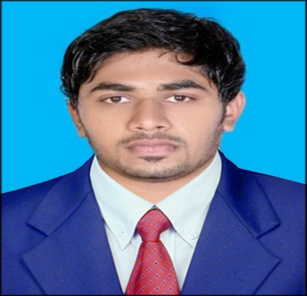  Languages Known:  English(Good)  Hindi(Good)  Malayalam(Good)  Tamil(Good)  Arabic(Manageable) |  | Career Objective :
To obtain a long-term career with an organization, that provides good opportunity for enhancement of professional and personal status. I firmly believe in the principle of implementing my duties with dedication and determination.
Strength :
- Good interpersonal and communication skills.
- Be quick to learn with strong attention to detail.
- Very flexible and able to adapt quickly to a changing and fast–paced environment.
- Can work under pressure.
- Self-motivated.

Employment Details :
- Worked as Network Administrator in Flash Innovations, Bangalore, India
(Feb 2015 – Oct 2016)
- Configure and manage network devices like Juniper (Ex 4200) switches, Cisco (1700, 1900, 1800, 2900, 3845, ASR 1002X, 1006 series routers and switches), Nexus (2K, 5K), and HP MSR series routers.
- Perform the Installation and Configuration of new Routers and Switches. Configuration of Routing Protocols OSPF, BGP, Static Routes.
- Monitoring network performance Through Network monitoring tools like WhatsUpGold and keep records of Traffic flows of core links
- Conducted an audit of the existing network configurations and made necessary modifications/Tuning for the better performance.
- Generation of Network documents, Inventory management records and Network outage reports.
- Configurations and troubleshooting of all Routers & Switches.

Academic Profile :
- MCA 2015 Bangalore University-Karnataka, India
- BCA 2012 Calicut University-Kerala, India
- HSE 2006 GOVT OF HSE BOARD-Kerala, India
- SSLC 2004 GOVT Board of Public Examination - Kerala, India

Computer Skills :
- Technology : C, C++, Java, ASP.Net, PHP, HTML
- Networking : CCNA
- Database : SQL Server 2005
- Operating System : Windows, Linux
- Software Testing : Manual Testing, HP Quality Center, Load Testing
- Tools Used : Pivotal Tracker, Test Link, Jmeter
Technical Skills :
- Routing: OSPF, EIGRP, RIP and BGP, Policy Based Routing, Redistribution, Route Filtering, Route-map.
- Switching: VLAN, VTP, RSTP, MST, InterVLAN Routing, Switching.

Computer Certifications :
- Cisco Certified Network Associates (Cisco ID: CSCO13058932)
- Undergone NIIT Certification on ASP.NET
- MS OFFICE
- CTTC
- DIPLOMA IN JAVA

Project / Summery Internship :
Fitness Centre Management “Software using VB.NET
Title: Fitness Centre Management
The software has been developed for “Power Fitness Centre “,which can monitor and maintain The database information about members, staff and equipment of the center easily, efficiently and quickly.

A website on “Online College Management” using ASP.NET
Title: Gems college Online
The website has been developed for Gems college, Malappuram in an effort to make it as attractive and dynamic as possible. Compared to the existing site a database has been added to Project. Thus parents can find academic details about their children such as marks, attendance as fees details.

A website on “ RESTAURENT MANAGEMENT SYSTEM “ using java
Title: ZamZam monitoring system
To develop a dynamic website service for a restaurant chain in which the management can monitor and maintain the database information about sales and purchases details easily, efficiently and quickly.

A website on “ Online Modelling of Pro Active Moderation System” using java
Title: Online Modelling of Pro Active Moderation System
To develop a website service for user to buy and sell product and service online, which benefits everyone In terms of convenience and profitability.

Declaration :
I, hereby declare that all the information given above are true and correct with the best of my knowledge and I bear the responsibility of the above mentioned particulars.

