Curriculum Vitae

PERSONAL DETAILS

NAME: Rasim
Rasim.319166@2freemail.com
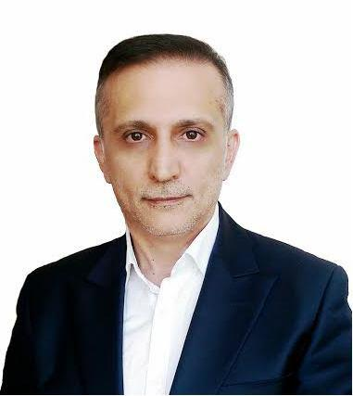

OBJECTIVES

To pursue a career whereby my creative, technical and innovative skills and experience can be effectively and efficiently put to use and developed with a scope for future professional growth of organization and personal.

WORKING EXPERIENCE :

Total 27 years (15 years working in CIS countries – 12 years in U.A.E)

2009 – Till Date R-STUDIO INTERIOR DESIGN LLC -Dubai, U.A.E
(Managing Director )

2007 – 2009 Villion House General Trading LLC -Dubai, U.A.E.
(General Manager)

1

2006 | – 2007 | NDL Steel Production FZC -Sharjah, U.A.E.
 |  | (General Manager)
2004 | – 2006 | NDL Steel Production FZC -Sharjah, U.A.E.
 |  | (Sales Manager)
2000 | - 2004 | BakuElectroStamp JSC -Baku, Azerbaijan
 |  | (Sales and Marketing Manager)
1992 | – 2000 | Togrul Trading Ltd. –Baku, Azerbaijan
 |  | (Owner)
1989 | – 1992 | The State Radio and TV Company- Baku, Azerbaijan
 |  | (Engineer)
EDUCATION BACKGROUND:
1986-1992 |  | : Master Degree in Engineering and Design of Electronics
 |  | Azerbaijan Polytechnic University

COMPUTER SKILLS

- Windows, IOS for Mac

- Microsoft Office

- Corel Draw

Any additional information can be provided upon request.

2

