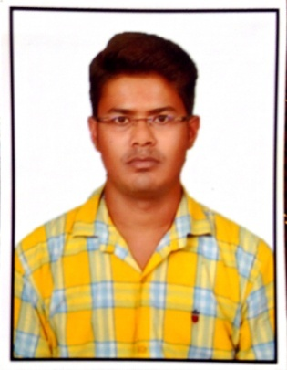

Personal Information

First Name

email

Nationality
Date of Birth
Gender

Desired Position

Work Experience

Dates
Position
Company
Responsibilities

Employer / Address

Dates
Position
Responsibilities

Employer / Address
Type of Business

Curriculum vitae

Lucky

Lucky.319200@2freemail.com

INDIAN

14.05.1990

Male

Civil Engineer

June 2015 - at present date

Civil Engineer / Site Engineer

RAJ ASSOCIATES.
- Oversee construction and maintenance of facilities.
- Supervise subcontractors and coordinate between suppliers and vendors of the company.
- As civil engineer, forecasted the cost, quantity and budget of the engineering equipment, manpower and labor.
- Ensure safety by monitoring the site.
- Responsible for work division to complete the project within time and quality.
- Was the focal point of construction and civil works in this site and project simultaneously
- Studying and implementing deferent construction methods.

Harihar Singh Road,Morabadi,Ranchi,Jharkhand,834008

2007
High Schooling
D.A.V Public School, Gandhi nagar C.C.L Ranchi Jharkhand.

54%
C.B.S.E

2010
Intermediate

Chota Nagpur college,Ramgarh Cant, Jharkhand.

63.7%
J.A.C

2011-2015
B.Tec (Civil Engineering)

JAIPUR NATIONAL UNIVERSITY (RAJASTHAN)

56.10%

- Ability to rapidly build and set uptrust
- Confident and determined
- Ability to cope up with different situation
- Active listener
- Team player
- Eye for detail
- Quick learner

- AUTO CAD (basic knowledgeable)
- Microsoft office word, Microsoft office excel, Microsoft office powerpoint
- Internet Browsering

Education and Training

year
Qualification Awarded
Institution
percentage
board

year
Qualification Awarded

Institution

percentage
board

year
Qualification Awarded

Institution

percentage

Interpersonal Skills

Computer Skills

ADDITIONAL INFORMATION

Curriculum vitae

DECLARATION: I do hereby declare that above information is true for the best of my knowledge.

DATE :__________________ LUCKY

