YASHER

Career Objective:
To work in an intellectually stimulating and globally competitive environment, engaging in challenging assignment, where my talents are well utilized, thus benefiting an organization as well as, helping me advance in my career.

Educational Qualifications:

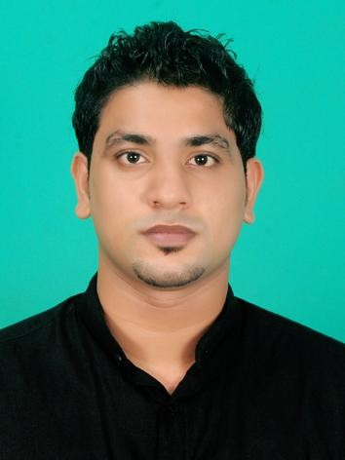

Email: yasher.319229@2freemail.com

Personal Information:

Age : 25 yrs
Date of Birth : 23/11/1989
Gender : Male Nationality : Indian Marital Status : Single
Languages known: English,Malayalam, Tamil

Bachelor of Mechanical Engineering
Dr. M.G.R Educational And
Research Institute University Chennai, Tamilnadu, India May 2013

Higher Secondary Vidyaprakash Public school CBSE
Vadakara, Calicut, Kerala, India
March 2009.

S.S.L.C.
Darul Huda English Medium School
CBSE
Nadapuram, Calicut, Kerala, India
March 2007

OTHER ACADEMIC PROFICIENCY:

• AUTO CADD 2D

• Completed professional HVAC training program from AXIONZ Training Institute,Calicut
1) Heat Load Calculation

2) Equipment Selection

3) Air Distribution System

4) Ventilation & Exhaust Systems

5) Piping

6) Static Pressure Calculations

7) Pump Selection

8) Air Conditioning Concepts
Projects /Research

Mini Project: DESIGN AND FABRICATION OF PORTABLE FOLDING CYCLE.

Main Project: INCREASING THE EFFICIENCY OF THE BOILER BY REDUCING THE COMBUSTION LOSS IN PACKAGED BOILER HOUSE

Work Experience :

Target Source Maintenance and Contracting Company (Doha,Qatar)

working as MEP and civil site engineer under this company .I have been working as MEP and
Civil engineer for the past one and half year(May 2015-Till Date). Below mentioned are some of the major sites

1) The land in pearl Qatar
2) Java U Coffee Shop in pearl Qatar
3) Java U Coffee Shop in B Square Mall
4) Doha Clinic Hospital

Key Responsibilities:

• Review and coordinate design drawings and specifications to ensure compliance with project requirements.
• Perform and implement value engineering proposals on the design.
• Assist in preparing the Quality Plan including organizational chart, work program schedule, material acquisition plan, shop drawings plan, subcontracting plan,
general method statement, inspection and testing plan, safety plan, forms and checklists.
• Control and guide all electrical subordinates, subcontractors and specialist suppliers.
• Handle all electrical submittals including shop drawings, material & systems, method statements.
• Interface management with the client and consultant representatives, local authorities, and interface contractors.
• Developing procurement strategies for subcontractors/ suppliers in terms of packaging and scope of works
• Monitor the site progress and lead the construction team to ensure proper implementation on site in compliance with project schedule, quality standards, electrical codes
and local regulations.
• Identifying bottlenecks, resolving technical problems in design and construction.
• Tackle all correspondences related to the electrical discipline.
• Tackle the Engineer’s Instructions issued by the client and related variations.
• Coordinate between electrical discipline and all other project disciplines.
• Guide the QA/QC electrical team for proper installations & material inspections.
• Handle testing, commissioning, startup and handing over to the client.

Competencies

• Willingness to learn new concepts
• Good leadership qualities and interpersonal skills
• Committed to deadlines and schedules
• Systematic and hardworking

Co-Curricular Activities

• Participated in Best manager competition in college level

Hobbies
.
• Travelling

• Sports

• Group activities. (youth oriented activities)
Declaration

I hereby declare that all the details furnished above are true and best of my knowledge.

