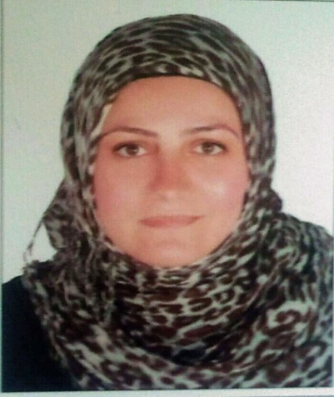

E-Mail: raida.319276@2freemail.com

Curriculum Vitae

Name : Raida

Date of Birth : August7th 1973

Nationality : Syrian

Marital Status : Married

Sponsor : Under Husband's residence

Objective : To contribute towards the growth and development of a growing organization that offers challenging opportunities and appreciates performance.

Education : 1.Applied Science University, Amman-Jordan, High Diploma of Computer Science of IT, June 1993.

2. High Diploma of Business Administration, Al Khwarizmi International College, Abu Dhabi, 2011

Training Courses :
-Certificate of Attendance (for successfully completing the Continuing

Professional Development) in Behavior Management, May 2014.

-Completed TOEFLE IBT,Al Khwarizmi International College,Abu Dhabi,February 2011.

- Power Point 2010
-Microsoft Access 2.0, NDC,Abu Dhabi
-Business Meeting, NDC, Abu habi
-Microsoft Project: Creating Project Schedule, NDC, Abu Dhabi

-Microsoft Excel Advanced, (Zenith Training Institute), Sponsored by NDC, Abu Dhabi
-DOS, M.S Windows, WinWord& Excel, (Zenith Training Institute), Sponsored by NDC, Abu Dhabi

Languages : Arabic: Fluent in Speaking, Reading & writing “Native”.
English: Fluent in Speaking, Reading & writing.

Professional Experience

- From July 2015 up to date

Position: - Ex. Secretary

Dubai Stars Electro mechanic contracting

- From January 2014 – July 2015

Tender Moments Nursery

Position: -Ex. Secretary &English Teacher for KG1 & KG2

- From June1995 – February1999

NATIONAL DRILLING COMPANY (NDC)

Position: -Executive Secretary for the Financial Manager &Secretary of the Accounts
Section
Responsibilities:
- Receive all incoming correspondence and distribute the same to the concerned authority.
- Prepare correspondences for both internal and external distribution.
- Filing and document control of all correspondence and other related documentation.
- Prepare reports and other matters when assigned by concerned authority.
- Ensure timely archiving of files/documents/records as per archiving procedures.
- Be conversant with the company's document and record control procedure and ensure
implementation of stated requirements in the area of responsibility.

- From April1994 toFebruary1995

ABU DHABI OIL COMPANY(ADOC)
Position:Receptionist.

Responsibilities:
- answer telephone, screen and direct calls
- take and relay messages
- provide information to callers
- greet persons entering organization
- direct persons to correct destination
- deal with queries from the public and customers
- ensure knowledge of staff movements in and out of organization
- monitor visitor access and maintain security awareness
- provide general administrative and clerical support
- prepare correspondence and documents
- receive and sort mail and deliveries
- schedule appointments
- maintain appointment diary either manually or electronically
- organize conference and meeting room bookings
- co-ordinate meetings and organize catering
- monitor and maintain office equipment
- control inventory relevant to reception area
- tidy and maintain the reception area

Copies of qualifications and certificates will be provided upon request.

SKILLS

- Excellent communicator, able to liaise effectively with people at all levels.
- Thrives on new challenges.
- Have mature and responsible approach to work and adapt easily to new situations.
- Have Patience to deal with the clients.
- Initiative and accepting changes.

