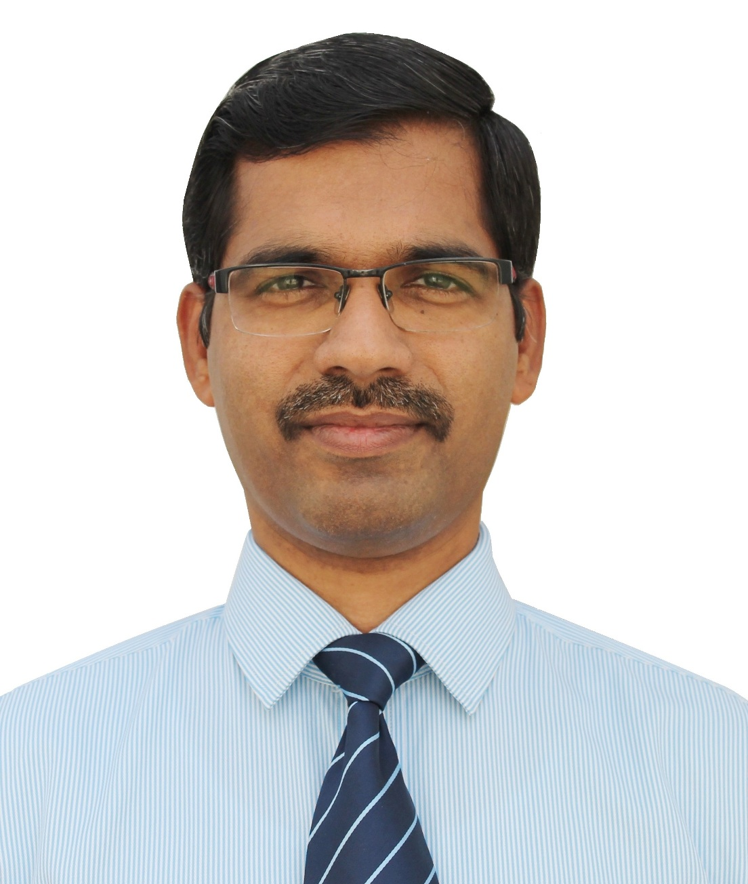

**MANOJ**

ACCOUNTS CUM PURCHASE OFFICER

[Manoj.319356@2freemail.com](mailto:Manoj.319356@2freemail.com)

**PROFESSIONAL SUMMARY**

A diligent Commerce graduate with 12 years U.A.E. experience in finance and accounts; responsible for preparing MIS reports, Monthly Budgeting, Project accounting, Bank, supplier, general ledger reconciliation, Purchase and Banking; reporting to Finance Controller.

***EXPERIENCE IN U.A.E.: 12 YEARS (SINCE* - JULY 2004)**

**M/s. National Transport & Contracting Co., U.A.E. (**visa of Tariq Contracting & Gen. Maint. Co.**)**

**Accountant -** March 2006 – June 2016

**DUTIES & RESPONSIBILITIES:**

* Preparing MIS reports, project wise financial reports, accounts payable report, aging report, Purchase reports monthly and annually.
* Preparing bank accounts reconciliation, general ledger reconciliation, Supplier’s accounts reconciliation & reconciling, tallying monthly purchase accruals and pending purchase register and making necessary journal entries.
* Presenting a true and fair view of the financial position of the company by preparing consolidated financial statements, Trial Balance, P&L Account, Balance Sheet.
* Processing month end accounts payables, preparing cheques, meet with clients, Received, recorded, and banked cash, cheques, and vouchers as well as reconciled records of bank transactions.
* Responsible for purchase register and ensuring the entire invoices received against monthly purchase orders. Verify and process entire invoices and ensure transactions are correctly recorded.
* Meeting with suppliers for Negotiating price, establishing terms, quality requirements, delivery, and contracts.
* Keeping the price stability for full projects as well as trying to maintain same price for upcoming projects.
* Preparing & processing requisitions, purchase orders, LOI & Chasing the delivery.
* Mentor junior accountants.
* Attending to the auditors and solving and answering their query.
* Reporting to the Finance Controller. (MANOJ) Page 1/4

**JULY 2004 TO FEBRUARY 2006**

M/s. Al Ryum Cont. & Gen. Trans. Est., (Landscaping) Abu Dhabi, U.A.E, as a Purchase Clerk

**DUTIES & RESPONSIBILITIES**

* Preparing Weekly and monthly Project wise Purchase Report
* Controlling the purchase and supply of all procured items & services.
* Negotiating price and terms of products with suppliers.
* Keeping the price stability for full projects as well as trying to maintain same price for upcoming projects.
* Meeting with suppliers, Establishing terms, pricing, quality requirements, delivery, and contracts.
* Adhering to all company policies with particular regard to accounting procedures.
* Reviewing all contracts/agreements to achieve ‘best price/best quality’ purchasing.
* Coordinate with Storekeepers in order to ensure availability of critical stock items.
* Preparing & processing requisitions, purchase orders & Chasing the delivery.
* Maintaining records of supplier contracts, agreements, goods ordered, received.

**EXPERIENCE IN INDIA ( 10 ½ years) (FROM OCT 1993 TO MAY 2004)**

1. M/s. Pintu Texnit Pvt. Ltd., Noida, India as an Accounts Officer from **APRIL 2002 TO MAY 2004**

**DUTIES & RESPONSIBILITIES:**

* Preparing the MIS report
* Preparing the Trial Balance
* Preparing the Trading Profit and Loss Account and Balance Sheet
* Checking the Party`s Delivery Notes & Invoices, invoice discrepancies and taking the appropriate action; Posting the invoices; Aging of Accounts and Preparing the Invoice for payment.
* Preparing the Vouchers ( Cash, Bank, Journal )
* Calculating the TDS and depositing in the bank
* Maintaining the General Ledgers with Computer
* Handling the Payables & Receivables
* Preparing the Bank & Party`s Reconciliation Statement, analyzing and investigates the discrepancies when and why they occur.
* Attending to Auditors

(MANOJ) Page 2/4

1. M/s. A.M.L. Exports International, New Delhi, India as a Finance cum Accounts Officer from **SEPTEMBER 1999 TO MARCH 2002**

**DUTIES & RESPONSIBILITIES:**

* Preparing MIS report
* Preparing the Trial Balance
* Preparing the Trading Profit and Loss Account and Balance Sheet
* All Bank dealings
* Checking the Party`s Delivery Notes & Invoices, invoice discrepancies and taking the appropriate action; Posting the invoices; Aging of Accounts and Preparing the Invoice for payment.
* Preparing the Vouchers ( Cash, Bank, Journal )
* Calculating the TDS and depositing in the bank
* Maintaining the General Ledgers with Computer
* Handling the Payables & Receivables
* Preparing the Bank & Party`s Reconciliation Statement, analyzing and investigates the discrepancies when and why they occur.
* Attending to Auditors
* Handling the Cash

1. M/s. New Delhi Export House, Noida, India as Finance cum Accounts Officer from **APRIL 1995 TO AUGUST 1999**

**DUTIES & RESPONSIBILITIES:**

* Preparing the MIS report
* Preparing the Trial Balance
* Preparing the Trading Profit and Loss Account and Balance Sheet
* Preparing the Bank & Party`s Reconciliation Statement, analyzing and investigates the discrepancies when and why they occur.
* Preparing the Vouchers ( Cash, Bank, Journal)
* All Bank dealings
* Preparing and submitting the documents for L/C , Bank Guarantee
* Preparing and submitting the Export Documents in Bank
* Arranging the funds by purchasing the Export Bills ( AABC / PC/B.G.)
* Chasing the payments from overseas customers
* Making the forward exchange contract booking
* Attending to Auditors (MANOJ) Page 3/4

1. M/s. VNP Import Export Pvt. Ltd., New Delhi, India as an Accounts Assistant from **NOVEMBER 1993 TO MARCH 1995**

**DUTIES & RESPONSIBILITIES:**

* Checking the Party`s Delivery Notes & Invoices, invoice discrepancies and taking the appropriate action; Posting the invoices; Aging of Accounts and Preparing the Invoice for payment.
* Preparing the Vouchers ( Cash, Bank, Journal )
* Calculating the TDS and depositing in the bank
* Maintaining the General Ledgers with Computer
* Handling the Payables & Receivables
* Handling the Cash
* Prepare & Checking the Pay Rolls
* Salary Distribution

**PERSONAL DATA**

Date of Birth 11-01-1973

Sex Male

Marital status Married

Educational qualifications B Com passed with first class from the

University of Calicut, Kerala, India in 1993.

Studying CMA

Computer skills MS Office, Tally 6.3 (financial package)

FOCUS, Internet & E-mail

Language known English, Hindi, Malayalam

(Write, read & speak)

Visa status Employment Visa (Abu Dhabi)

**MANOJ**

(MANOJ) Page 4/4