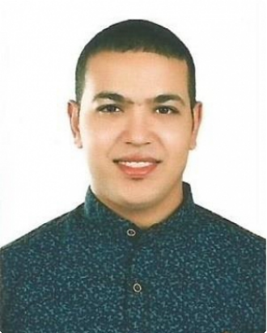Peter

E-mail :
peter.320171@2freemail.com
Address:
DUBAI,UAE – Visit Visa

Work experience

EL-Faraana Reef Resort in Sharm al- Shiekh
Mechanical Engineer
May 2011 — Sep 2016

- Oversees the Green Building Regulations & Specifications quality control.
- Undertake all swimming pools cleaning processes
- Undertake and supervise the installation and maintenance of different types of security systems in residential room buildings and their integration with other fire and life safety systems.
- Working on the construction of different types of swimming pool systems and water features
HVAC " split , window and DX air conditioning units" maintenance ,Diagnosis problems and completes repairs quickly and efficiently to satisfy each customer. CAD-design and worksheets via ICDL.
Performed general office duties and administrative tasks. Prepared weekly confidential sales reports.
Managed the internal and external mail functions.

Qualifications

Computer-Aided Design (CAD) . Excellent communication skills.
ICDL " Microsoft office, word and powerpoint". Strong mechanical and electrical skills. Material accountability.
Fast learner.
highly dependable.

Education

BSC in Mechanical Engineering July 2009 — July 2015
Faculty of Engineering, Alexandria University, Egypt.

Graduated with a general grade "GOOD" and with an "Excellent" grade in the graduation project. Graduated with the Fifth rank among all my class colleagues.

Education Background

- Internal combustion engines , Turbines ,HVAC systems, Economy, Ship cost estimation, fluid mechanics, fire-fighting systems, safety regulations, SOLAS, Naval architecture, Ship design, Hydro-dynamics, Structure analysis, pumps and compressors.

Languages

Arabic : Native - Mother tongue.
English : Excellent written and spoken " a certificate from the American Institute of languages sponsored by
NatGeo foundation and Cengage university in USA".
German : Average " A2 level certificate from Duolingo online website".

Special information born in 29 sep 1991

Profession : Mechanical Engineer
Nationality : Egyptian

Interests

Reading, Surfing the internet, Solving puzzles and playing football.

References

References available upon request.

