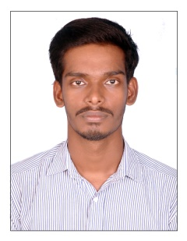
VISHNU

VISHNU.320436@2freemail.com

B TECH IN CIVIL ENGINEERING |

EDUCATION

B.TECH | CIVIL ENGINEERING | CUSAT (COCHIN UNIVERSITY OF SCIENCE AND TECHNOLOGY) | 2015

- Completed degree from College of Engineering pathanapuram
- Focused in Civil Engineering
- Passing out in 2015 with 64.76 %
- Active member in civil engineering association .

HSE | BOARD OF HIGHER SECONDARY EXAMINAION |2010

- Completed from KRGPM HSS
- Focused in science group.

WORK EXPERINCE

KOCHI METRO | SUPERVISING IN TRAFFIC SURVEY | CIVIL ENGINEER

- Assisting in the traffic survey for Kochi metro
- The survey was done by data corp
- Counting the number of vehicles and pedestrians by using camera, face to face interview and pneumatic tubes.
- By using this data, deciding the width and nature of footpath and pocket roads.
ASSISTANT ENGINEER | AF INFRA STRUCTURE PVT. LTD | 09/2015 – 10/2016

- Assisting in the infrastructure development
- Supervising in the installation of APPOLO drum mix plant (DM 60 )
- Worked as a plant engineer in the installation of DM60 [Foundation to finishing]. The time duration of installation is 3 months. This plant has an output of 120 tone /hr.
- Supervising in the construction of 60 km two lane road with paved shoulder’s n NH-47 including two major bridges and a minor bridge. NH-47 one of the major Highway in Kerala state.
- Worked as a quality engineer in mix plant .executing quality lab tests: - Bitumen Extraction, Sieve analyzes, etc.
- Managing the work schedule of labors, drivers and supervisors.
- Estimating the required materials mainly bitumen, aggregate, fuels, etc.
Technical qualification

- Knowledge in CAAD
- Knowledge in 3Ds max
- Basic knowledge in STAAD pro
- Completed a training course in highway construction

Project undertaken

- Experimental Investigation on Impact of Quarry Sand Content on Mechanical Properties of High Performance Self-compacting Concrete.
- This project was approved and financed by CERD (Centre for engineering research and development)
- This is one of the most relevant topics at present. Due to the unavailability of river sand, the construction industry looking for next method.
- High performance self-compacting concrete is one of the innovative idea.

Elective subjects

- Highway & airfield pavement design management
- Cost effectives building techniques

*References : Available on request
****

