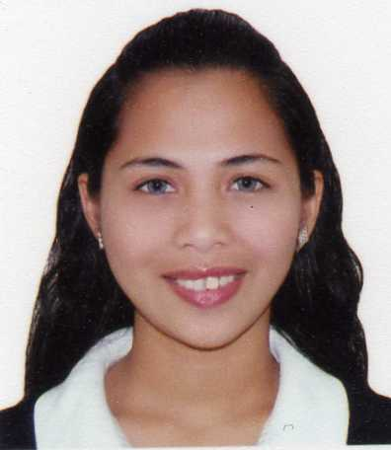
PINKY
Contact No. C/o 0501685421
E-mail: pinky.320566@2freemail.com

OBJECTIVE
- To secure a challenging positionin a work environment which provides professional growth,and where I can bring value and enhanced productivity to my employer while advancing my career, developing my skills and gaining further experience.

PROFILE
- A fast learner, meticulous and ambitious. Distinct ability to relate to several types of people. Seeking constant learning and exposure.

WORK EXPERIENCE

June 15, 2013- up to Present
AL RAHMAH HOME NURSING/ DUBAI, UNITED ARAB EMIRATES
Job Description and specifications:
REGISTERED NURSE
- Takeblood pressure, measure heartbeat and evaluate medical condition of patients.
- Giveprescribed medications
- Inject insulin
- Clean Tracheostomy Tube
- Provide proper hygiene and grooming of the patient
- Assist patient when travelling
- Accompany patient through every hospital check up
- Administer colostomy care and put pouch bag.
- Fully versant with all medical proceduresrequired of a nurse.

April 10, 2010 – May 20, 2013
CAINTA MUNICIPAL HOSPITAL/PHILLIPINES
Job Description and Specifications:
ER Nurse/OB-GYN ward/ PEDIA ward/OR nurse/Delivery Nurse
- Provide direct quality care to patients including daily monitoring, recording and evaluating of medical conditions.
- Develop and direct a rotational system in managing the care of patients in the department.
- Supervise the admission of patients in emergency cases and directly transferring of patients from their locations to the hospital via ambulance.
- Lead and mentor 10 newly license nurses in developing and achieving professional expertise.
- Interact and communicate with patients of all ages and ethnic backgrounds, administer quality medical care and treatment.

PERSONAL CERTIFICATIONS:

DHA PASSER – REGISTERED NURSE
Dubai - United Arab Emirates

PRC LICENSE – REGISTRED NURSE
LICENSE NUMBER - 0605428
Philippines

Language
ARABIC - conversant
English - fluent
Tagalog - native speaker

PERSONAL DETAILS:

Nationality: Philippines
Gender: Female
Date of Birth: February 3, 1988
Age: 27 years old
Visa Status: Employment
Marital Status: Single
Religion: Roman Catholic

“I hereby certify that above information is true and correct to the best of my knowledge and belief”

_____________________
Pinky

