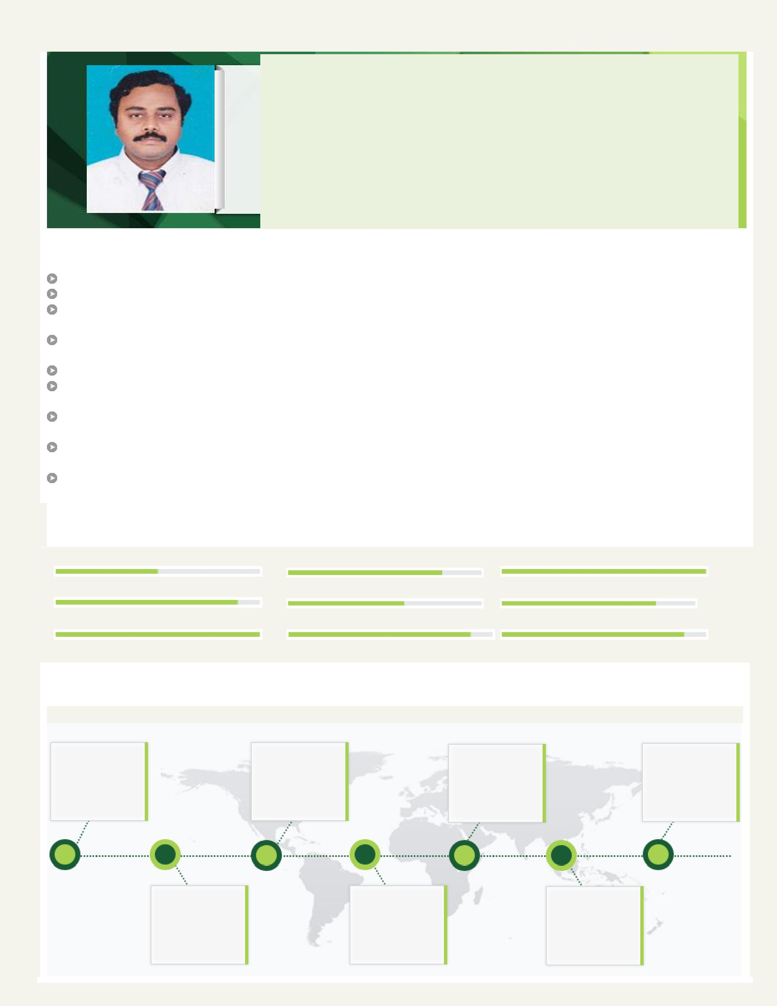
Tamil
Tamil.320659@2freemail.com

Civil Engineer / Draughting

A versatile, high-energy professional with the merit of executing prestigious projects of large magnitude within strict time schedules, cost & quality

Industry Preference:

Construction

Location Preference:

UAE

Profile Summary

Diploma in Civil Engineering with over 23 years of experience in Project Management & Civil Construction Management Exposure of working in different countries like India, Malaysia, Qatar & UAE

Skilled in planning, executing and spearheading construction projects involving project development, contract administration & resource planning

Competent in swiftly ramping up projects with competent cross-functional skills and ensuring on-time deliverables within pre-set cost parameters
Competent Civil Engineer, with experience of change composition the delivery of industrial projects

Experience in pre-stressing detailed drawings with sound knowledge of construction methods & sequences in civil structural constructions

Dynamic Engineer with a flair for adopting modern project execution methodologies, systems and procedures in compliance with quality standards

Expertise in ensuring smooth integration of engineering design, construction activities and transfer into the operational phase, while working closely with internal & external advisers and client representatives
Achievement-oriented professional with excellent people management skills and capability to manage change with ease

Area of Excellence

Project Management | Construction Management | Safety Management
Cost Control | Quality Assurance | Site Administration
Contract Administration | Liaison & Coordination | Resource Optimization

Career Timeline

May’04 – Dec’15
ETA-ASCON | Jan’99 – Jul’00 | Jun’94 – Apr’97 | Jun’89 – Aug’91
 | Aljaber Energy | Warsaw Engineers | Arul and Chola
Dec’26 – Till Date | Services |  | Property
 |  |  | Promoters
AL MEMZAR CONTRACTING

Jun’02 – Jun’03 | May’97 – Aug’98 | Sep’91 – Apr’94
Kettaneh | YTL Civil | Allied industrial
 | Engineering | Designers
Construction

Work Experience

Dec’26 – Till Date | AL MEMZAR CONTRACTING, U.A.E. Civil Engineer
May’04 – Nov’15 | ETA-ASCON, Dubai, U.A.E. as Civil Engineer
Jun’02 – Jun’03 | Kettaneh Construction, Qatar as Bar Bending Engineer
Jan’99 – Jul’00 | Aljaber Energy Services, U.A.E. as Site Engineer
May’97 – Aug’98 | YTL Civil Engineering, Malaysia as Site Engineer
Jun’94 – Apr’97 | Warsaw Engineers, Bangalore, India as Senior Engineer
Sep’91 – Apr’94 | Allied industrial Designers, South Arcot District, India as Site Engineer
Jun’89 – Aug’91 | Arul and Chola Property Promoters, Madras, India as Site Supervisor
Role across the tenure:

Performed feasibility studies for identifying scope and executing the interior projects on time
Reviewed & ensured quality is checked during inspection & testing of supplied products & raw material

Executed the projects as per the specifications and tender documents
Prepared correspondence letters for coordinating with the clients & contractors

Conducted site meetings with contractor & sub-contractors and documented minutes of meetings

Provided instructions to the foreman regarding all types of interior and building construction works
Ensured proper follow-up for ensuring materials requirement is met as per the drawings & specifications

Managed step-to-step construction activities related to the quality and progress according to architectural drawing and specifications

Negotiated prices with contractor, sub-contractor and suppliers for work order

Highlights:

Took measures like conducting trainings for the team member to conclude projects on time and within budget in given time

Played a key role in adding new revenue streams by winning the Safety Awards

Improved the execution of project and ensured quality work is delivered to the clients

Managed new projects like Dubai Parks Hotel-1 and faced & overcome key challenges like fast track project.

Received appreciation from clients Deyaar for executing 3B+gf+39 Storey Commercial & Residential Tower on plot U2 at JLT timely

Certifications / Trainings
Basic Fire-fighting and Personnel Protective Equipment/Borouge Petro Chemical Project

Lifting and Crane Operations/ Borouge Petro Chemical Project
Risk Assessment and STAART Card System/ Borouge Petro Chemical Project

Education

Diploma in Civil Engineering from Chengal Varaya Naicker Polytechnic (C.N.T.), Madras in 1989

IT Skills
AutoCAD, Multisuite, CADSRC and MS Office (Word, PowerPoint & Excel)

Personal Details
Date of Birth: | 3rd January 1968
Permanent Address:
Present Address:
Nationality: | Indian
Marital Status: | Married
Languages Known: | English, Hindi & Tamil
No. of Dependents: | 2
Visa Status: | Residence Visa
Passport Details: | (Issued at Dubai, UAE. Valid up to 07/10/2024)
Driving License Details: | UAE Valid Driving Licence

For other details, please refer ANNEXURE:

ANNEXURE

Projects Undertaken

Title: | G+1 Villa - 3nos , Service Block & Majlis Block (4 Nos)
Consultant: | Future Design Consultant, R Qitects & Team 90 Architect and Consultants.
Project Value: | AED 25 Millions
Role: | Civil Engineer
Title: | Dubai Parks Hotel-1 at Jabal Ali
Client: | Dubai Parks & Resorts
Project Value: | AED 50 Millions
Role: | Civil Engineer (Structure works)
Title: | Bollywood Parks at Jabal Ali
Client: | Dubai Parks & Resorts
Project Value: | AED 55 Millions
Role: | Civil Engineer (Structure works)
Title: | P-30 Proposed G+4+R Multi Storey Car Parking Building & P-30 Proposed B+G+M+ 4/7 Storey Mixed
 | Development for Dafz – Dubai, UAE
Client: | Government & Dubai Air Port Free Zone
Project Value: | AED 135 Million
Role: | Civil Engineer
Responsibility: | Managed car parking and 7 storey structure works
Title: | Abu Dhabi New England Center for Children of Educational and Residential Building (Project Managemen
 | Hill International)
Consultant: | Leo –A-Daly Dar-El-Emara
Project value: | 145 Millions
Role: | Civil Engineer
Title: | 3B+GF+39 Storey Commercial & Residential Tower on Plot U2 at JLT
Client: | Deyaar
Consultant: | DAR
Project Value: | AED 160 Million
Role: | Site Engineer
Responsibility: | Engaged in the construction of tower project of 39 floors structure and finishing works of the same and
 | completed in schedule time
Title: | Jumeira Lake Towers – Car Park
Client: | EMAAR
Consultant: | WSAP
Project Value: | AED 440 Millions
Role: | Site Engineer
Title: | Summit Tower, Dubai
Client: | ETA Star Property Developers, L.L.C.
Consultants: | DAR Consultants
Role: | Site Engineer
Responsibility: | Completed construction of 12 floors structure
Title: | CUC4 - Dubai Airport Projects
Client: | Dubai Civil Aviation

 |  | Consultant: | DAR & Al Andasa
 |  | Role: | Site Engineer (In-charge of Reinforcement works)
 |  | Title: | 750 MW Power and Water plant for the Ras Laffan Power Company Ltd. & American Energy Services (J.V.)
 |  |  | at Ras – Laffan Industrial City, Qatar
 |  | Project Value: | U.S. $ 39 Million
 |  | Contractor: | ENEL Power S.P.A., Italy
 |  | Role: | Site Engineer (Structure works)
 |  | Title: | LNG Storage Tank for Ras Gas Ltd. in Ras Laffan Industrial City, Qatar
 |  | Project Value: | US $ 35 Million
 |  | Contractor: | Ishikawa Jima Harima Heavy industries Co., Ltd., (IHI) Japan
 |  | Role: | Bar Bending Engineer
 |  | Title: | Taweela Power Station Extension Projects, Phase-II, Abu Dhabi, UAE
 |  | Contractor: | Eastern Bechtel Inc.
 |  | Project Value: | US $ 1 Billion
 |  | Role: | Site Engineer
 |  | Title: | Borouge Petro Chemical Project, Ethylene Unit, UAE
 |  | Contractor: | Alliance Bechtel Linde
 |  | Project Value: | US $ 600 Million – 600 kta, ethylene unit
 |  | Role: | Site Engineer
 |  | Title: | RITZ Carlton Apartments (42 Floors), National Art Gallery in Kualalumpur, Malaysia
 |  | Project Value: | RM 300 Million
 |  | Role: | Site Engineer (In-charge of Reinforcement works)
 |  | Title: | Construction of Steel Plant for Mukunth Steels of M/s Kalyani Steels & Ferro Alloys Ltd. at Bellary District
 |  |  | Karnataka, India
 |  | Project value: | IRS 130 Million
 |  | Role: | Senior Engineer
 |  | Title: | Tanfac SUL Phuric Acid Plant at Cuddalore S.A. Dist. & SPIC Anti Biotic Complex, India
 |  | Project Value: | IRS 100 Million
 |  | Role: | Site Engineer
 |  | Title: | Commercial Complexes & Apartments at Madras, India
 |  | Project Value: IRS 50 Million
 |  | Role: | Site Supervisor

