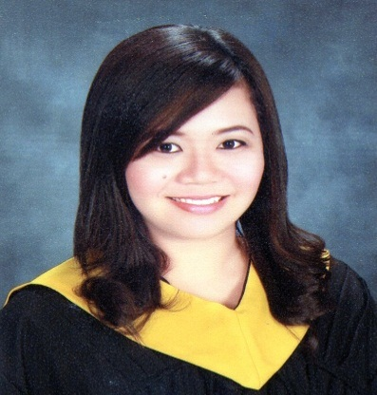
ABIB
ABIB.320817@2freemail.com

OBJECTIVE
To apply and enhance my knowledge, working ability and to acquire experiences that will provide satisfaction, both for personal and organizational goals.

EDUCATIONAL ATTAINMENT

Bachelor of Science in Accountancy (Graduate)
Bataan Peninsula State University
Balanga City, Bataan, Philippines
June 2010- April 2014

WORK EXPERIENCE/ SPECIAL TRAININGS

Human Resources and Development Assistant- Payroll In- charge
Sanyo Denki Philippines Inc., Subic Bay Freeport Zone, Philippines
December 2014- September 2016
- Accommodate inquiries regarding Human Resources and Payroll concerns
- In-charge in time keeping and payroll processing
- In charge in preparation and computation of 13th month pay and bonus of employees
- Prepare bank advice for payroll crediting
- Prepare and arrange Pay slip of employees
- Prepare last pay computation for resigned employees
- Prepare monthly reports on all government dues
- Implements applicable government updates on new wage order and benefits.

On-the-job Training
Provincial Assessor’s Office- Balanga City, Bataan, Philippines
May 2013
- Records and classify the appraisal, assessment and valuation of real properties which shall be used as basis for taxation

SEMINARS ATTENDED

Seminar on Income Taxation
SGV and Company- Makati City
June 2015

Seminar on Bangko Sentral ng Pilipinas
Bataan Peninsula State University- Balanga City, Bataan, Philippines
September 2013

KEY SKILLS

Proficient in Written and Oral English
Computer Literate
Knowledge in Filing and Bookkeeping
Dedicated and Hardworking

PERSONAL INFORMATION

Date of Birth : March 29, 1994
Civil Status : Single
Citizenship : Filipino
Language Spoken : English & Filipino

I hereby certify that the above information is true and correct to the best of my knowledge and belief.

