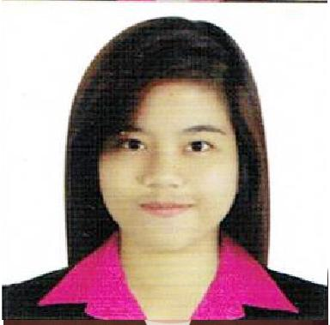
MELROSE
MELROSE.320845@2freemail.com

______________________________________________________________________________

OBJECTIVES

Looking for a challenging and responsible position in a growth oriented Company to use my extensive knowledge and prove myself in terms of technology with innovative ideas and become most valuable person for organization.

SKILLS AND QUALIFICATIONS

- Knowledgeable in Database Management System using MS Access, MySQL.
- Knowledgeable in Adobe Photoshop, Prezi Presentation Software,Google Sketch Up.
- Knowledgeable in NetSuite.
- Knowlegdeable in Microsoft Office Applications (Word, Powerpoint, Excel).
- Can perform Clerical and Administrative tasks
- Customer Service
- Call Center Service Operations.
- Complaint Handling/Dispute Resolution
- Data Entry/Records Management
- Multiline Phone Use

Experience

IT Group Inc,
November 2014- July 2015
Quezon City
Receptionist / Guest Service Agent

Exposed and trained as a receptionist / guest service agent. I was trained to handle administrative tasks as well like organizing and schedule meetings and appointments of my supervisor. It’s also my duty to answer calls and queries, distribute email, correspondence memos, letters, faxes and forms and assist in the preparation of regularly scheduled reports.

Teleperformace
August 2015 – October 2016
EDSA Central IT Center 2
United St., Cor. EDSA, Greenfield District
Mandaluyong City 1554, Philippines
Customer Service Representative

Exposed and trained as a Customer Service Representative. It was my duty to take calls and provide solution to customers concern. It was also my duty to maintain customer satisfaction.

EDUCATIONAL ATTAINMENT

Tertiary : Lyceum of the Philippines University
Capitol Site, Batangas City

Bachelor of Science in Computer Science

2011 - Present

Secondary | : | Batangas National High School
 |  | Rizal Ave., Batangas City
 |  | 2007- 2011
Primary | : | Pisa Elementary School
 |  | Pisa Tingloy, Batangas
 |  | 2000 – 2006
ORGANIZATION AFFILIATION

Lyceum of the Philippines University-Batangas Computer Society Vice President

2012 – 2013

SEMINARS AND TRAININGS ATTENDED

Leadership Seminar – “Equipping an IMPACT Team of Leaders towards Teamwork and Excellence in Service”

Lyceum of the Philippines University – Batangas July 26, 2013

Pre-Employment Orientation Seminar LPU Batangas,Capitol Site Batangas City
September 3, 2013

Be a Wise Saver Forum on Responsible Banking Lyceum of the Philippines University - Batangas December 9, 2011

Joomla! Front End Training
IT Group Inc., Topy Main Building., EconomiacorCalleIndustria St, Bagumbayan, Quezon City
November 7, 2014

PERSONAL INFORMATION
Age | : | 20
Date of Birth | : | February 27, 1995
Gender | : | Female
Civil Status | : | Single
Height | : | 5’1”
Weight | : | 50 kg.
Nationality | : | Filipino
Religion | : | Roman Catholic

I hereby certify that the above information is true and correct according to my knowledge and belief.

