RESUME
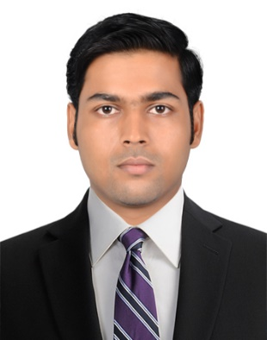
VINOD
VINOD.321017@2freemail.com
Electrical & Electronics Engineer

PERSONAL SUMMARY

A self-motivated electrical and electronics engineer with working experience of multi storey buildings electrical and power equipments installation, maintenance and its operational management.

SUMMARY OF EXPERIENCE

- 11Month experiences in a reputed property developers in India as site engineer
- 1 Year experience in operation and maintenance of power equipments up to 66KV substation in Kerala State Electricity Board as operation and maintenance Engineer

WORK EXPERIENCE

Organization : YEM KEY ASSOSIATES, Nilambur, Malappuram, Kerala
Role : Site Engineer
Duration : September 2014 to August 2015

- Preparation of Electrical Layout Drawing

- Preparation of Electrical Load Calculation

- Preparation of Electrical Schematic Diagram

- Material Specification

- Responsible for timely ordering of electrical materials

- Site coordination and man power management

- Site Visit for work quantity and quality check

- Communication with the client and the contractor

Organization : Kerala Electricity Board, Kozhikode, Kerala, India
Role : Operation and Maintenance Engineer.
Duration : August 2015 to August 2016

JOB OBJECTIVES:

Operation and maintenance of:
- Transformers up to 16 MVA(66/33kv,66/11kv)
- SF6 circuit breakers ,MOCB(66kv),VCB(33/11kv)
- Various types of relays such as over current relays, Earth fault relays, Distance relays, Auto Re-closure relays and Microprocessor relays etc.
- CTs, PTs, Lightning arrester etc.
- Laying and Termination of control cables in 66 KV Yard equipment’s.
- 66KV 10 MVAR Capacitor bank.
- 110 volt, 200 Ah battery and battery charger.
- Fire Fighting systems.
- Power equipment testing devices such as Megger up to 5 KV, Brake down voltage testers

SOFTWARE KNOWLEDGE

- AutoCAD, CGlux, MS Office

TRAINING & COURSE ATTENDED

- MEP Electrical Designing and Drafting
- IOSH Health and safety management
- Medic First aid

LANGUAGE

English, Hindi, Malayalam
ACADEMIC
COURSE | INSTITUTION | UNIVERSITY | YEAR OF PASSING
B-Tech (Electrical Engineering) | AWH Engineering College  Kuttikkattoor,  Calicut | Calicut | 2014

PERSONAL DETAILS

Date of Birth : 08th May1992
Nationality : Indian
Gender : Male
Marital Status : Single
I hereby declare that all the above information given by me is true to the best of my knowledge and belief.

