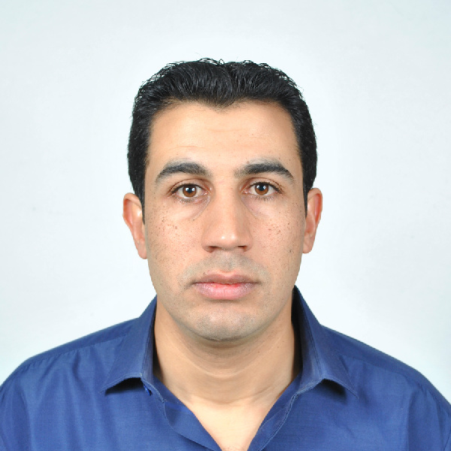 | Name: MOKADEM  Date of birth: 07/08/1981 at. Youb  Marital status: single  Nationality: Algerian Mechanical engineer  Available immediately  Email: mokadem.321217@2freemail.com  Visa validity: 26/11/2017 – 24/02/2018

EDUCATIONS
2010
BOUMERDES-ALGERIA
Oil and gas Mechanical engineer
at Algerian petroleum institute (IAP) boumerdes (Algeria)
http://www.iap.dz/fr/

2009
BOUMERDES-ALGERIA
The English language training
at Algerian petroleum institute (IAP) boumerdes (Algeria)

2006 (3 month)
practical internship on industrial maintenance at SNTF www.sntf.dz
2006
SIDI BEL ABBES-ALGERIA
Mechanical engineer
(energy option)
at university djillali liabes Faculty of Engineering
https://www.univ-sba.dz

1999
SAIDA-ALGERIA
Scientifically "baccalaureate"
at secondary school malek bennabi,youb
SKILLS  - I have a good experience on construction (piping, equipment installation, steel structures, HVAC…)  - Project management  - ability to make decisions  - troubleshooting  - able to displace at national and international | ARABIC: GOOD  ENGLISH: GOOD  FRENSH: GOOD  COMPUTER KNOWLEDGE:  AUTOCAD; NAVISWORKS; SOLIDWORKS; GAMBIT; ANSYS FLUENT; MS OFFICE, EXCEL, WORD; INTERNET

WORK EXPERIENCE

July 2015 – October 2015  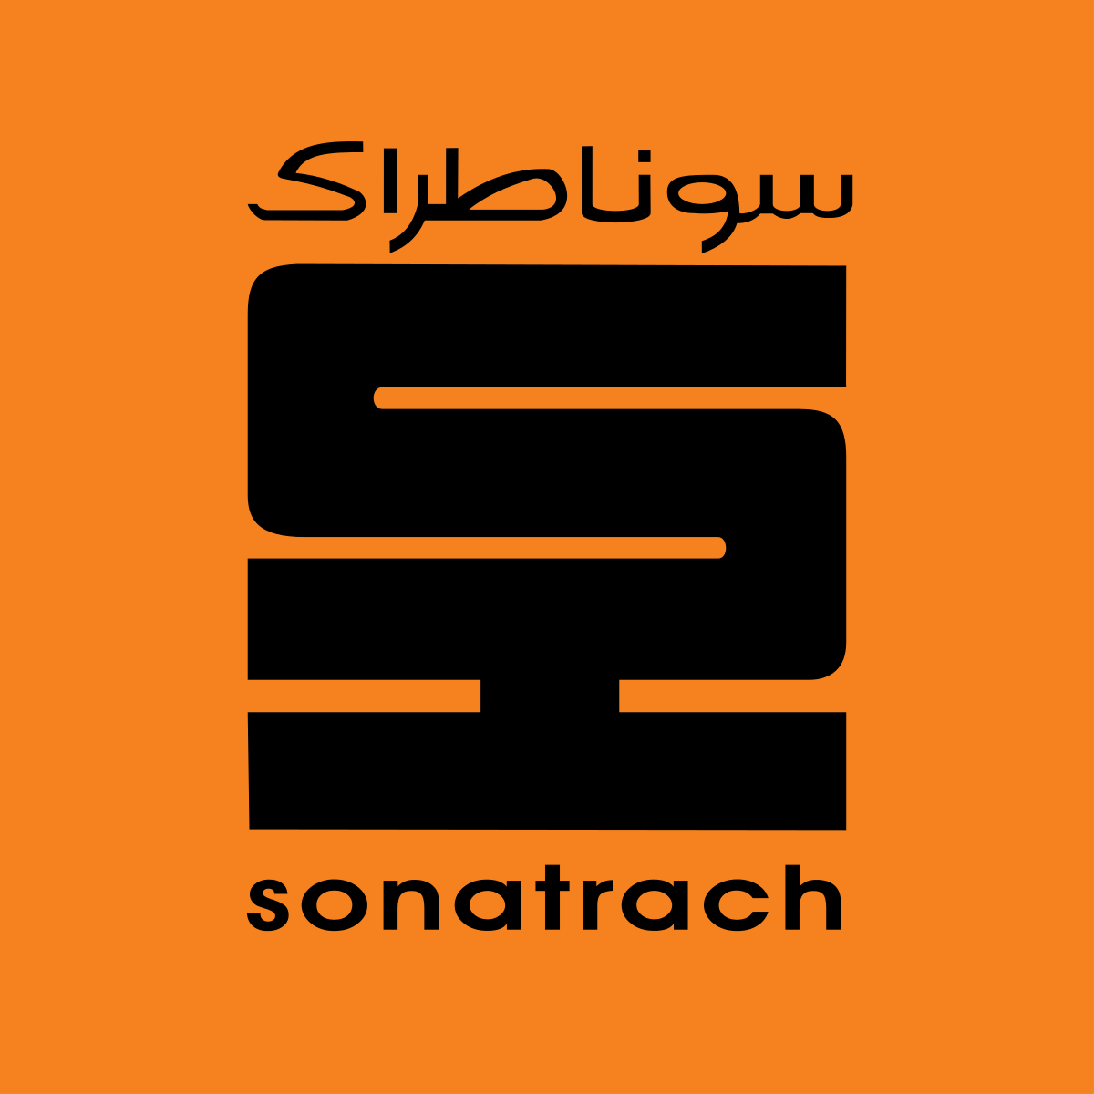 
TOUATGAZ-ADRAR- ALGERIA
ENTREPRISE NATIONALE DES GRANDS TRAVEAUX PETROLIERS (ENGTP), OIL&GAZ engineering, industrial construction… http://www.engtp.com
mechanical engineer (superintendent)
realization of Center Processing Facility Client :(GDF) / sonatrach; (TR)
check procedure of construction, prepare, check plans, organize, coordinate and supervise, attend the meetings with client and suggest solutions

January 2013 – July 2015 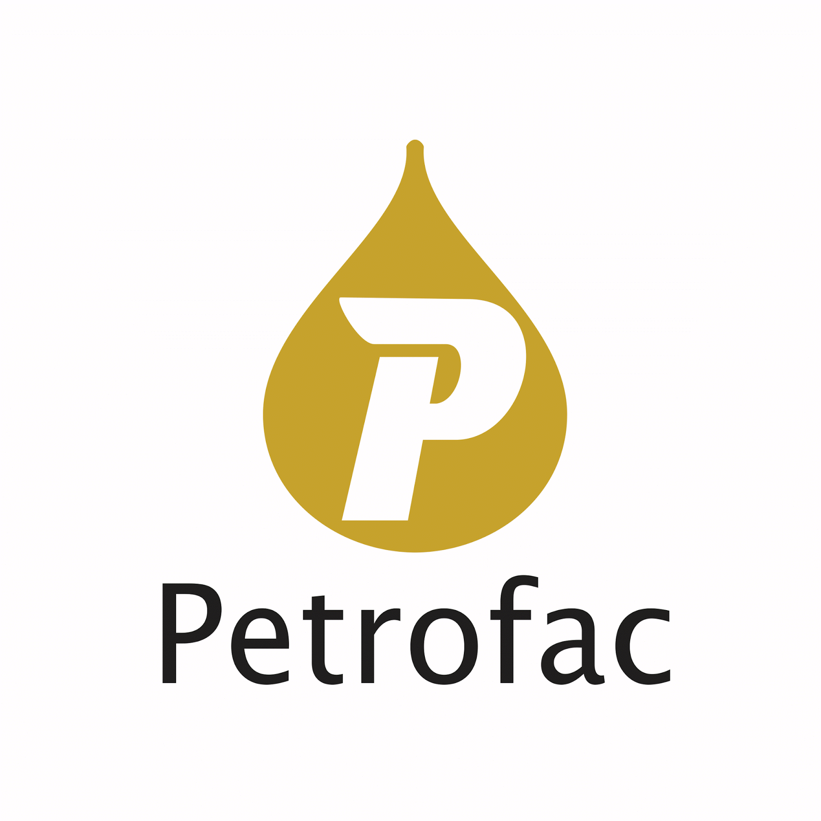 
HASSI MOUMEN-IN SALAH GAS- ALGERIA
ENGTP, OIL&GAZ engineering, industrial construction…
mechanical engineer (superintendent)
realization of Center Processing Facility Client petrofac / sonatrach; BP; Statoil
prepare, check plans, organize, coordinate and supervise,
attend the meetings with the clients and suggest solutions
join 2011 - January 2013 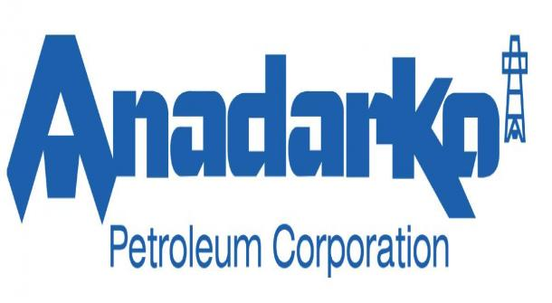
EL MERK-HASSI MESSAOUD - ALGERIA
ENGTP, OIL&GAZ engineering, industrial construction…
mechanical field engineer
realization of Center Processing Facility Client petrofac / sonatrach; Anadarko
supervise, coordinate, troubleshoot and suggest solutions
Mars 2011 – join 2011
HASSI R’MEL- ALGERIA
ENGTP, OIL&GAZ engineering, industrial construction…
mechanical engineer (engineering)
engineering at hassi r’mel
design, draw plans, coordinate with field engineers
October 2010 – mars 2011 
HASSI R’MEL- ALGERIA
ENGTP, OIL&GAZ engineering, industrial construction…
QA/QC
fabrication of spools at workshop in hassi r’mel Client: saipem/sonatrach
Control the quality of products (CND (PT, RT, UT, heat treatment...))
and prepare reports

OTHER INFORMATIONS
I hold driving license Practice sports: football; volley-ball; swimming;
Clear national service and all obligations chess….
non-smoker

