RESUME

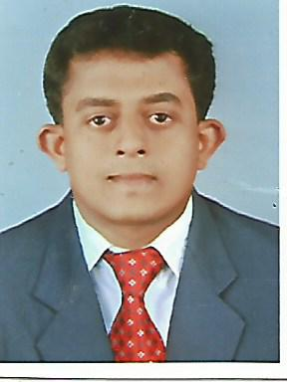
AJITH
AJITH.321434@2freemail.com

CAREER OBJECTIVE

Seeking for a job to start career in a well-settled and highly professional organization. Ability to grab career advancement through large efforts and innovative work techniques.

PROFESSIONAL EXPERIENCE
COMPANY NAME: JSF HOLDINGS PVT. LTD.
DURATION : 21-08-2013 to 17-10-2016
DESIGNATION : ACCOUNTANT
Key areas & Responsibilities
- Entries in the accounting system.
- Prepare Cash, Bank, payments & receipts.
- Manage Petty Cash and Cash Tally.
- Prepare Bank reconciliation and Suppliers reconciliation.
- Salary calculation of employees.
- Prepare Cash flow and Fund flow statement and summaries reports as needed.
- Manage all expenses and making monthly and weekly reports.
- ESI and PF calculation.
- Checking the daily report, Reporting and supervision.
- Manage Billing.
- Muster-roll keeping.
- Payment of the company.
- Checking the daily report, Reporting and supervision.
- Calculation of Raw material and Packing material consumption.
- Manage ESI and PF Register.
- Prepare Sales figure.

ACADEMIC QUALIFICATION

Examination | Specialization | School/College | University  Board | Year of passing | Percentage  /CGPA
MBA | Finance and Marketing | Srinivas School of Management,Mangalore | Mangalore University | 2013 | 73%
B.B.A | Finance | Ettumanoorappan College,Ettumanoor | Mahatma Gandhi University | 2010 | 60%

PROJECT UNDERTAKEN

- A Study on Working Capital Management of Keltron Component Complex Ltd, Kerala, India.

GREATEST STRENGTHS
- Dedication ………….. (Willingness to work the extra mile to achieve the excellence)
- Enthusiasm ………… (High level of motivation)
- Team player ………… (Feel comfortable to work with other team members)
- Empathy
- God Fearing
SEMINARS ATTENDED

- Attended seminars on management development programmes conducted by Srinivas School of Management.
- Attended seminars on different management subjects conducted by Srinivas School of Management.
- Seminar on Marketing Strategy and Economic variation. Facilitator:V.S Rama swami and Srinivas rao
awards and ACHiEVeMENT
- Participated in Marketing Game and Product Launching at Intercollegiate Management Meet organized by Srikrishna College of Engineering And Technology.

COMPUTER SKILLS

- Computer fundamentals.
- M.S Word.
- M.S Excel.
- Tally 9.

PERSONAL PROFILE

Date of birth | 16.02.1990
Gender | Male
Nationality | Indian
Language known | English, Malayalam.

DECLARATION

I hereby declare that the above mentioned information is correct up to my knowledge and I bear the responsibility for the correctness of above mentioned particulars.

