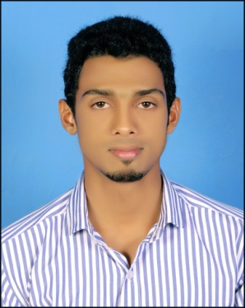
THOUSHEED
THOUSHEED.321725@2freemail.com
Master of Business Administration

Seeking positions in the field of Finance with an organization of repute.
SYNOPSIS

- A competent and skilled professional with around 3 and a half years of experience in
Finance.
- A versatile, analytical and hardworking person with practical hands-on approach.
- Possess excellent communication and presentation skills.

CAREER CONTOUR
Last position held: Accounts Manager at M/s. Kiran A Vasant Chartered Accountant & Financial Consultants

Responsibilities:
- Audit, Accounting and Taxation of small companies, partnership firms and sole-proprietary concerns
- Inspections Accounts books and Preparation of Audit Reports as External Auditor.
- Basic accounting through standard program like EXCEL
- Worked extensively in Accounting application software TALLY
- Tax Compliance

Job Description:
- Preparation of financials of sole-proprietary and partnership firms
- Data entry of Sales, Purchases, Expenses, Receipts, Payments, and Bank Transactions
- Managing a firm's financial accounting, monitoring and reporting systems
- Providing and interpreting financial information
- Computation of taxes, preparation of tax returns and filing of returns
- Preparation of Sales Tax returns and filing the returns
- E-payment of TDS, Preparation and filing of TDS
- Analysing change and advising accordingly
- Conducted internal audit and statutory audits of various firms
- Assisting with auditor to ensure annual monitoring of the clients is carried out
- Developing external relationships with appropriate contacts, e.g. clients, bankers and tax departments
- Producing accurate financial reports to specific deadlines
- Supervising staff and delegation of work responsibilities
- Keeping abreast of changes in finance and taxation field.

SCHOLASTIC

2015 Master of Business Administration from Sikkim Manipal University, KARNATAKA
2012 Bachelor of Business Management from Mangalore University, KARNATAKA, INDIA
2009 Pre Degree from Millagres Pre-University College Mangalore, KARNATAKA
2007 Secondary School Leaving Certificate from SHEMS, Manjeshwer, KERALA INDIA

TECHNICAL FORTE

- Well versed with Windows XP, Windows 7, Windows 10, MS-Office, Tally Enterprise resource planning (ERP) version 9, Winman CA ERP and Winman E-TDS.
- Have undergone and completed an advanced training course in Advanced EXCEL form Manipal Institute of Computer Education.
- Diploma in Computer Hardware and Networking from CTTI Mangalore.

PERSONAL SNIPPETS

Gender : Male
Date of Birth : 2nd February 1991
Religion : Muslim
Nationality : Indian
Languages Known. : English, Hindi, Malayalam and Kannada

References can be provided as and when required
References can be provided as and when required

References can be provided as and when required

References can be provided as and when required

