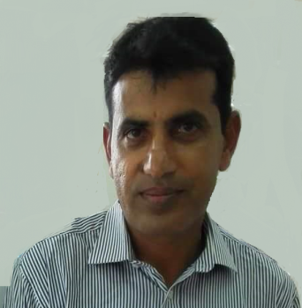
IFTIKHAR

IFTIKHAR.32924@2freemail.com

Objective:
Seeking to build a long term career in a growing construction company where I can achieve enough scope to utilize my experience. Looking for a career that can provide me unique learning experiences as well a steady growth.
Professional Experiences:
- Inma Company, Jeddah (KSA) May 2014- July 2017

Responsibilities: Worked as Insulator
- Remove old insulation and dispose of it properly.
- Read blueprints and specifications to determine job requirements.
- Determine the amount and type of insulation needed.
- Measure and cut insulation to fit into walls and around pipes.
- Fasten insulation in place with staples, tape, or screws.
- Use compressors to spray insulation into some spaces.
- Install plastic barriers to protect insulation from moisture.
- Follow safety guidelines.
Main Projects:
- Lulu Hyper Market
- Jeddah Airport

Alif-Nar Contracing, Jeddah (KSA) January 2013-April 2014
Responsibilities: Worked as Insulator

Al-Saif Contracting, Madeena (KSA) February 2009-November 2012

Responsibilities: Worked as insulator

- Al-Wazan Contracting, Kuwait June 2005- November 2008

Responsibilities: Worked as insulator
Academic Qualifications:

- F.A 2 years Second Division Year 1992
Jhang, Punjab, Pakistan

- Matric 2 years Second Division Year 1989
Jhang, Punjab, Pakistan

Language Skills:
Arabic Medium
English Medium
Urdu/ Hindi Fluent
Punjabi Fluent
Saraiki Fluent
Personal data:
Availability: Immediate, Available in UAE on Visit visa
Expiry of Visit Visa: 03-10-2017
Sex: Male
DOB: 01-01-1970
Marital Status: Married

