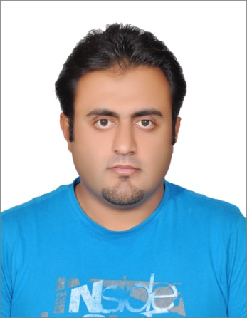
BILAL

E-mail: bilal.33474@2freemail.com

Objective:

To be a part of challenging and demanding working environment. Responsible approaches, honesty, commitment to my work are the tools. I have been equipped with to carve my way through.

Personal Information:

Name Bilal
Date of Birth November 29, 1982
Place of Birth Doha, Qatar
Gender Male
Nationality Pakistani
Religion Islam
Martial Status Married

Experience:
SITE ENGINEER / CAD OPERATOR (April 2010- June 2015)
HAIF CONTRACTING COMPANY KSA
Responsibilities were:

- Prepare site layout & surveying work.
- Control execution of work (Formwork-Excavation-Backfilling)
- Make surveying in each area.
- Issue inspection & test plans.
- Prepare cost estimates & project details.
- Collaborate with the team to ensure client satisfaction.
- Ensure proper safety precautions on the site for client satisfaction.
- Ensure proper supply of all equipment on the project.
- Organize meetings with consultant and ministry in the interest of the projects.
SENIOR SURVEYOR / CAD OPERATOR ARABIAN ROCK CONTRACTING COMPANY (March 2008 - July 2009)

Responsibilities were:

- Prepare site layout & surveying work.
- Control execution of work (Formwork-Excavation-Backfilling)
- Make surveying in each area.
- Issue inspection & test plans.
- Prepare cost estimates & project details.
- Collaborate with the team to ensure client satisfaction.
- Ensure proper safety precautions on the site for client satisfaction.
- Ensure proper supply of all equipment on the project.
- Organize meetings with consultant and ministry in the interest of the projects.

DATACONTROLLER
SHIFA INTERNATIONAL HOSPITAL ISLAMABAD
(October 2004 – September 2007)

Responsibilities were:

- Ensure entered data accuracy by comparing with basis documents & identified errors.
- Assist with purchasing & oversight of office equipment and supplies.
- Perform modifications, edits & deletions to the database based on authorized and approved documents.
- Identify problematic data during the entry and comparison process.
- Perform testing of data entry screens for database limits and review of data entry guidelines as requested.

AREA SUPERVISOR (February 2003 – March 2004) GROUP 4 SECURITIES UAE
- Supervising security personal.
- Carrying out close supervision of onsite security personal.
- Providing leadership, guidance and support to security staff.
- Professionally handling all sensitive and confidential information.
- Handling complaints in a diplomatic manner.

Education:

2005 DIT (Diploma in Information Technology)
NATIONAL INSTITUTE OF SCIENCE & TECHNICAL EDUCATION
ISLAMABAD, PAKISTAN

2002 DIPLOMA IN SURVEYING
PMDC INSTITUTE KHEWRA, PAKISTAN

2001 INTERMEDIATE CERTIFIACTE
GOVT. GORDON COLLEGE RAWALPINDI, PAKISTAN

1999 MATRICULATION CERTIFICATE
PAKISTAN AIR FORCE INTER COLLEGE
KALLAR KAHAR, PAKISTAN

Computer Skills:

- AUTOCAD 2D / 3D
- ARC VIEW GIS
- MICROSOFT OFFICE
- COMPUTER NETWORKING
- COMPUTER HARDWARE PROFESSIONAL

Driving License:

Valid SAUDI ARABIA Driving License for light vehicle Manual /Automatic

Languages:

- ENGLISH
- ARABIC
- URDU
- PUNJABI

