CURRICULUM VITAE
NAME : Palani
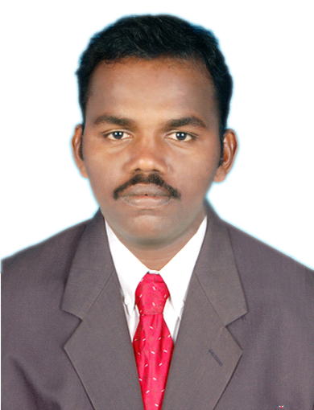

E-MAIL ID : palani.33910@2freemail.com

POST APPLIED FOR : CIVIL SUPERVISOR
OBJECTIVES :
To prove myself dedicated worth full & energetic as an civil engineer in a progressives organization that gives me scope to apply my knowledge & skills be a member of team that dynamically words success & growth of the organization.

EDUCATIONAL BACKGROUND

QUALIFICATIONS | NAME OF THE INSTITUTE | YEAR OF PASSING |  | PERCENTAGE
DIPLOMA IN CIVIL ENGINEERING | S.Thangapazham Polytechnic College,Vasudevanallur. | (2010-2013) |  | 74%
XII | Govt.Boys Higher.Sec.School,  Puliangudi | (2009-2010) |  | 63%
X | Senai Thaliver  Higher .sec.school  Puliangudi |  | (2007-2008) | 51%

PERSONAL DETAILS
DATE OF BIRTH : 19.04.1993
MARITAL STATUS : Single
NATIONALITY : Indian

LANGUAGES KNOWN : TAMIL & ENGLISH
EXPRIENCE : 2 YEARS
PASS PORT DETAILS
Date of issue : 22.8.2014
Place of issue : Madurai

PROJECT WORK : School Building

WORK DETAILS :prepare estimates, drawing, and survey, site supervisor

HOBBIES / INTERESTS : Reading Books, Volley Ball
ATTRIBUTES : Dedicated & Flexible
DECLARATION
I hereby declare that the above furnished details are true to the best of my knowledge.

