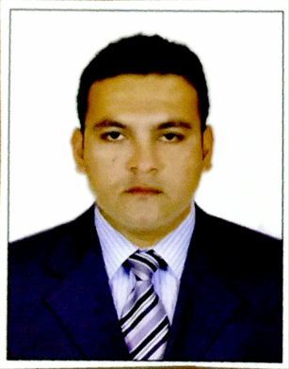
AQEEL

Cell No : C/o 971505891826
E-mail : aqeel.322215@2freemail.com
Gender : Male
Nationality : Indian
Visa Status : Tourist Visa (Valid Upto – Feb -2018)
___________________________________________________________________________

Career Objectives

Seeking professional role and a challenging long-term career in your esteemed firm where my abilities will be utilized to further enhance my Knowledge and Experience.

Resume Summary

Area of Expertise : Business Process Outsourcing & Marketing.
Total Experience : 5+ Yrs BPO/Voice Based BPO/Accent Trainer US & UK

Work Experience

Employer : Adroit Web Solutions
Designation : Team Lead
Period : June 2010 to Present
Location : India
Nature of Work : Understanding, Isolating & Providing with appropriate resolutions to the customer asking for a payday loan. Initially worked as a Trainer for UK & US Process.

Key Skills

- Strong communication skills (written and verbal)
- Good interpersonal skills with an ability to understand the customer’s problem and solving them
- Training new employees and getting them productive quickly
- Problem resolution.

Responsibilties

- Promote flexibility, service mind, and passion towards BPO products to the team.Proactively work towards business growth
- Manage team comprising of 30,50 people and report to Director.
- Set, review, report and enhance team productivity and performance in a proactive approach. Analysis and well-defined solutions required.
- Continuously develop team expertise.
- Internal and External clients management
- Anticipating potential needs and problems of customers
- Ideology is always being friendly and easy going person to explore and learn all possible aspects.
- Monitor calls to ensure positive customer experience and provide direct feedback on observed performance.

Achievement :
- Offered “Best employee of the month” for replying and solving to maximum number of support tickets within a stipulated time

Personal Data :

Date Of Birth : 16-Oct-1982
Religion : Islam
Marital Status : Single
Languages : English, Hindi, Urdu, Arabic
Likes: Playing Snooker, Cricket, Chess, Surfing on Web and Community Services

Academics

- B.Com – Osmania University
- Intermediate (M.P.C) – Board of Intermediate Education, Hyderabad.
- Secondary School Certificate –Board of Secondary Education, Hyderabad.

Declaration:

I hereby declare that the above mentioned details are true to the best of my knowledge.

Date :
Place: United Arab Emirate’s (AQEEL)

*****
*****

