SAMUEL
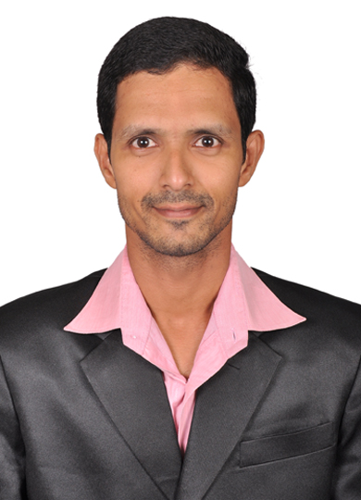
SAMUEL.322272@2freemail.com

Career Objective:
To fortify my career by making a mark in the field concerned showcasing the nurtured talent procured over the years and win the accolades of the employer who could provide me an opportunity to work.
EDUCATIONAL PROFILE

Technical Qualifications:

Knowledge of Computers like Ms-office.
Academic Profile:
Master of Arts in English from Madurai Kamaraj University, Madurai,
Tamil Nadu, India.
Bachelor of Arts in English from Bharat Institute of Higher Education and Research,
Tamil Nadu, India.
WORK EXPERIENCE:
- Worked as part time Lecturer in English at St. Paul’s Junior College, Bhadrachalam, Khammam,Telangana,India (2002-03).
- Worked as an English Lecturer in A.P.S.E.B Government Junior College, Paloncha, Khammam,Telangana,India (2002-03).
- Worked as an English Lecturer in Government Junior College, Khammam,Telangana,India (2004-05).
- Worked for Manair College of Computer Sciences as Assistant Professor of English, Khammam,Telangana,India (2005-09). Taught Soft Skills to MCA Students.
- Worked for PPIT Engineering College (Pulipati Institute of Technology and Sciences) as Assistant Professor of English, Khammam,Telangana,India (2009-10).
Taught Soft Skills, Communicative English, Life Skills to B.Tech 2nd Year, MBA Students.
- Worked for KITS Engineering College(Khammam Institute of Technology and Sciences) as Assistant Professor of English, Khammam,Telangana,India
(2012-14). Taught Soft Skills, Communicative English, Life Skills to B.Tech 3rd Year Students.

- Worked for Harvest Public School as CBSE English Teacher for High School
(Grades 8-12) in the year (2015-16),Khammam,Telangana,India.
- Worked for Edu Bridge Learning Pvt. Ltd (Government of India recognized Education Company) as a Training Executive(Executive Trainer), (Soft Skills,
Life Skills,etc), Khammam, Telangana, India.
ACHIEVEMENTS:
- Attended Teacher-Text-Student Interaction Programme in JNTU held on
13th ,14th of December 2013,Hyderabad,India.
- Selected by Progressive English Medium School, Sharjah, UAE in 2014 as English Teacher for 10+2 students.
- Attended Soft Skills Training Program at MLR Institute of Technology and Certified by IEG-JKC(Institute of Electronic Governance-Jawahar Knowledge Center).
- Certified by Edu Bridge Learning Pvt. Ltd Recognized by “National Skill Development Corporation” (NSDC) Government of India as a Trainer.
STRENGTHS:
Patience
Smart Working
Zeal to learn fast
Punctuality
Personal Profile:

Date of Birth : 30th August1977
Marital Status : Divorced.
Children : One Male Child.
Languages Known : English, Hindi and Telugu

)

