MUNEES.322484@2freemail.com  MUNEES  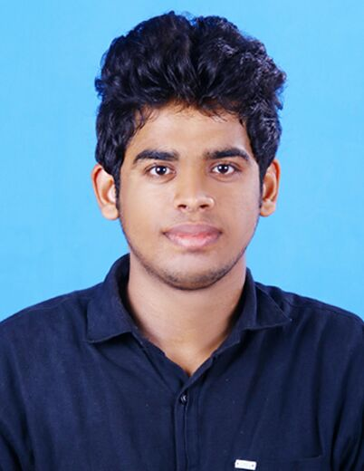  PERSONAL INFORMATION:  Date of Birth: 18/03/1993  Gender : Male  Marital Status :Single  Nationality : Indian  Visa status : visit  LANGUAGE PROFICIENCY  English  Malayalam  Hindi (Read and Write)  Arabic (Read and Write) | Career Objective  MBA graduate in Marketing & Finance from a reputed institute, MES College of Engineering under University of Calicut -India, having 1 year of experience in the Administration & Marketing Field. Ready to accept all kinds of challenging and responsible jobs that offers challenging working environment where I can utilize my knowledge and skills in a positive direction and contribute towards the overall objectives of an organization.  Current position: Marketing Executive.  Company :ERAM MOTORS Pvt. Ltd,  Experience Summary- 1 year in the field of Administration & Marketing.  PROFESSIONAL STRENGTHS  Comprehensive problem solving abilities, positive thinking, innovative, self-motivated and good natured personality. Can easily adapt to different working environments and ability to work under pressure. Proficient in Business and formal communication, both in oral and written.  CORE COMPETENCIES-  - The ability to develop and communicate goals in support of the business’ mission.  - The Operational Executor administers the day-to-day work of managing people inside the organization.  - Good Document Management Skill.  - Employee Management & Talent Management.  - Capability to conduct the Recruitment Events.  - The ability to demonstrate concern for satisfying one’s external and/or internal customers.  - Advertising and Sales Promotion, Branding and Positioning &Content Marketing.  - Customer Experience Management Customer Relationship Management.  - Digital Marketing Integrated Marketing Communications.  - Good understanding of all financial functions and auditing.  ACHIEVEMENTS.  - Became best male anchor of the management meet program conducted by MES College of Engineering Kuttippuram.  - Won cash prize in management meet conducted by Ilahia College Eranakulam, Nehru College….  - Participated in more than five management meet conducted by several colleges under Calicut University.  - Conducted two days South Indian Management meet (Executive member) “MESMERIZE ’15” with participants from more than 50 colleges across south India.  - Selected as Best outgoing student of commerce department in 2014.
Academic Qualifications
COURSE | MAJOR | BOARD/UNIVERSITY | YEAR
MBA | Marketing & Finance. | Calicut University | 2016
BBM | Management | Kannur University | 2014
PLUS 2 | Science | State Government | 2011
SSLC |  | State Government | 2009

TECHNICAL SKILS
Operating Systems : | Windows 7, 8,10
Applications : | MS. Office Packages, Email & outlook,  Photoshop, Typing Skill

MAJOR PROJECTS
- Successfully completed 45 days project titled “A study on factors influencing purchase decision of customers towards Mahindra XUV 5OO at Eram Motors Private Limited, feroke chungam”.
- Successfully completed 21 days project titled “A study on customer satisfaction at Sulfex Mattress Company, Kannur.
Employment History
Eram Motors Pvt. Ltd, Calicut India,
Designations: Administration Assistant and Marketing Executives

SCOPE OF WORK: Marketing Executive.
- Contributing, and developing, marketing plans and strategies;
- Liaising and networking with a range of stakeholders including customers, colleagues, suppliers and partners of the organization.
- Evaluates marketing reports and sales data for management reporting.
- Managing the production of marketing materials, including leaflets, posters, brochures, newsletters, and online advertising
- Organizing and attending events such as conferences, seminars, receptions and exhibitions;
- Compiling and distributing financial and statistical information
- Monitors competitor activity and brainstorms potential improvements or changes in marketing strategy, products, or services.

SCOPE OF WORK: Administration
- Administration and execution of HR function including Recruitment & Selection, Compensation and Benefits.
- Maintain the HR data base and regularly update the personnel information.
- Prepare and place advertisements for recruitment.
- Assists in interviewing, hiring, orientation, and training of new marketing department staff.
TRAININGS ATTENDED
- Attended in 'Misbecone' National seminar conducted by MBA Department of MESCE, Kuttippuram.
- Participated in ‘Management Training conducted by JCI’ held at MES Keveeyam college.
- Actively participated and successfully completed the training workshop on power communication program ‘mPower’ by Vertical Eye, Coonoor.
- Actively Participated in 3 day communication and placement training conducted by Autumn Spring Training Solutions, Bangalore
DECLERATION
I solemnly declare that all the information furnished above is factually correct and true to the best of my knowledge and I bear the responsibility for the correctness of the above mentioned particulars.

