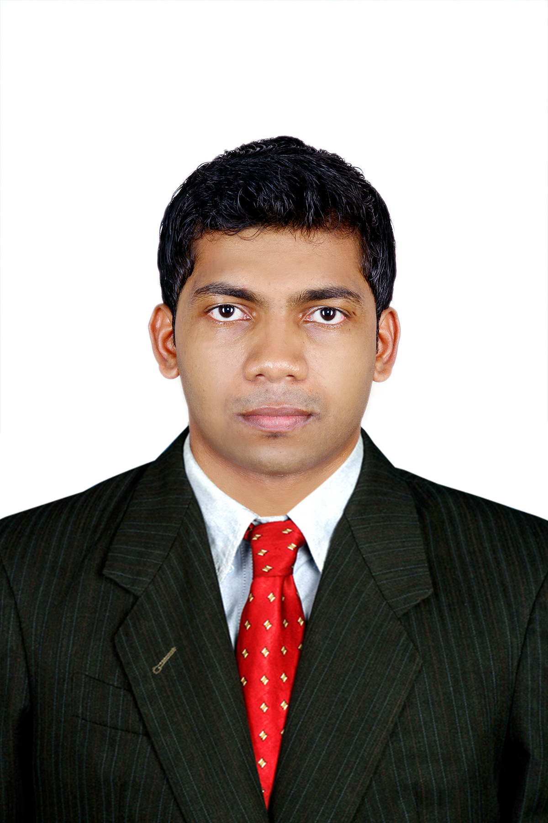
Date of Birth;
30/03/1991

Marital Status;
Single
Nationality; INDIAN
Religion;
Muslim
Visa Status;
Visit Visa 3 months
RESUME

MOHAMMED.322540@2freemail.com
Focused on excellence in the area of finance and accounts, with a dynamic, commercially focused and people-oriented organization, where, I can learn and grow by applying my professional and personnel skills and abilities.

EDUCATION

2011-2013 Master of commerce (M.COM-Finance)
Madurai Kamaraj University (Distance Edu)
Tamil Nadu, India.

2008-2011 Bachelor of commerce (B.COM)
MES KVM College, Valanchery
University of Calicut
Kerala, India.

SKILLS

- Accounting Software’s: TALLY, PEACHTREE, QB, M.S OFFICE.
- Good communication
- Organizing ability
- Internet and Computer related

TECHNICAL SKILL

Successfully completed Post Graduate Diploma in Indian and Foreign Accounting (PGDIFA) from the Institute of Professional Accountants (IPA) Calicut, Kerala, India.

EXPERIENCE

2012-2016 A.Geeri Pai Gold & Diamonds, Kochi, Kerala, India.
Accounts Executive
From Nov 2012 to Oct 2016 for 3 Year and Nine months.
Duties:-
- Prepare, examine, and analyze accounting records, financial statements, and other financial reports.
- Report to management regarding the finances of establishment.
- Analyze business operations, trends, costs, revenues, financial commitments, and obligations, to project future revenues and expenses or to provide advice.
- Prepares payments by verifying documentation, and requesting disbursements.
- Develop, implement, modify, and document record keeping and accounting systems, making use of current computer technology.

2011-2012 C.J Kunju Kunju, Chartered Accountant, Kochi, Kerala, India
Audit Assistant
From June 2011 to Nov 2012 for 1 Year and Five Months.
Duties:-
- Provide internal and external auditing services for businesses and individuals.

LANGUAGES
- English
- Hindi
- Malayalam
- Arabic (Read and Write).

DECLERATION
I, Mohammed do hereby confirm that the information given above
is true to best of my knowledge and belief.

Place: 17/11/2016
Date: Sharjah

