Ayesha  Ayesha.323231@2freemail.com | 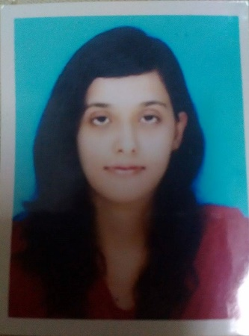
PROFILE:
OBJECTIVE: | To work with a dynamic and reputed organization that offers versatile opportunities for comprehensive career building and skill development. I am a highly-motivated individual, proactive with good communication and interpersonal skills. Capabilities of working in multitask, fast-paced and changing environment.

EDUCATION:
DEGREE | YEAR | INSTITUTION | GRADE/GPA
MBA  General Degree  Major Courses: HR & Marketing | 2011- 2013 | Fatima Jinnah Women University Rawalpindi Pakistan | 2.67
B.A  Majors: Economics, Political Science | 2008-2010 | F.G Post Graduate College for Women, Kashmir Road, Rawalpindi Pakistan | 1ST
F.A  Majors: Economics, Statistics | 2006-2008 | Fauji Foundation College for girls, new lalazar, Rawalpindi Pakistan | 1ST /A
MATRIC  Majors: Science | 2004-2006 | Fauji Foundation College for girls, new lalazar, Rawalpindi Pakistan | 1st /A+

WORK EXPERIENCE:
- 1year and 3 months teaching experience (Primary Level / Oxford curriculum) at The Educators, A Chain of Beacon House School System Rawalpindi Pakistan.
- 3 days’ community work at Al Mustafa Trust Hospital Chaklala Scheme III Rwp. (17th June – 20th June 2013).
- 2 months’ internship at Askari Bank Chaklala Scheme Rawalpindi. (16th July- 28th Aug 2012)

ACTIVITIES/ INTEREST:
- Travelling
- Reading
- Net surfing

KEY SKILLS:
- MS Office (Word, Excel, PowerPoint)
- Proficient in Internet & E-mail
- Good communication skills
- Capable of handling individual and group tasks.

LANGUAGES:
English, Urdu

MAJOR COURSES:
- Performance Management
- International HRM
- Strategic HRM
- Advertising

MAJOR PROJECTS:
- Research paper: Consumer perceptions about price promotions, Scratch and save promotions versus tensile price claims.
- Research: Impact of Sales promotional techniques on the sales of a company
Analysis of the HR functions of a private company.
- Analysis of Financial Statements: 10-year financial data of FFBQ.
- Advertising: Designed an ad campaign for an event management company.
REFRENCES
- Available on request

