.
AHMED
Mobile: C/o 0504973598, E-Mail: ahmed.323733@2freemail.com

In quest of assignments in Finance & Accounts functions with an organisation of repute

PROFESSIONAL PROFILE
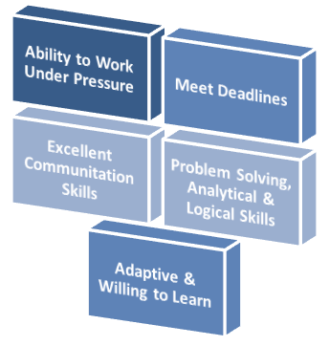
- A competent professional with 8 years of experience in the areas of Finance & Accounts, Auditing & Taxation and MIS.
- Experienced in spearheading a wide spectrum of Finance & Accounts activities encompassing finalization of accounts, cash flow management, taxation and auditing.
- Adept in monitoring the inflow & outflow of funds and ensuring optimum utilisation of available funds towards the accomplishment of corporate goals
- Keen understanding of the tax procedures and audits for the company
- Proficiency in streamlining the working procedures, formulating cost effective solutions for enhancing the accounting and taxation operations.
- An effective communicator with excellent interpersonal skills with proficiency in explaining complex financial data.

Areas of Expertise

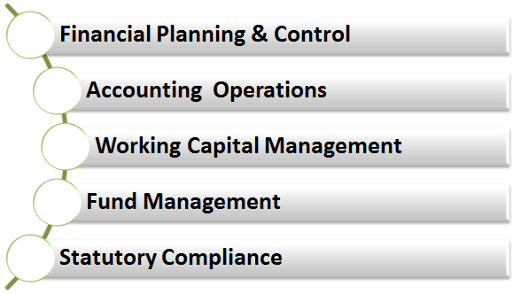
Finance & Accounts
- Maintaining accounts of the organisation, ensuring compliance with Accounting Standards and managing the consolidation / finalization of the Financial Statements.
- Analysing and planning the Financial Budgeting, Cash Flow for forecasting day to day activities.
- Preparing the working capital requirements and ensuring invoicing / Billing delivery as per SLA and ensuring timely collection of the payment activities.

Taxation & Auditing
- Coordinating with Auditors, finalising Tax Audit; evaluating internal control systems/ procedures with a view to highlight shortcomings and implementing necessary recommendations.
- Preparing tax plans and ensuring timely assessment and filing of Income Tax, Service Tax & T.D.S. returns in compliance with statutory acts.

Accounts Payables / Receivables
- Handling accounts payable - ageing of creditors/payables, releasing the payments as per terms/conditions.
- Managing receivable management -accounting of bills, debtors ageing, interacting with the customers for collection & sending the reminders for collections.
- Processing accounts payables for all three entities -ageing of creditors/payables, releasing the payments as per terms/conditions.

Budgeting / MIS
- Formulating annual budgets, cash flow statements and conducting various analysis to determine difference between projected & actual results and implementing corrective actions.
- Preparing MIS reports & various other financial reports to keep a track of the financial performances and submitting the same to Middle Management and Top Management.
CAREER CONTOUR

Jun’15: Square General Contracting Company, (Square Precast Factory) Dubai as Senior Accountant

Key Deliverables
- Overseeing the following functions
  - Check and approve all invoices for Suppliers & Subcontractors.
  - Managing the cost control for all factory expenses.
  - Preparing all sales invoices and follow the collection with the clients.
  - Calculating and recording asset, liability, revenue, and expenses entries by compiling and analysing account information.
  - Developing the details of assets, & closing entriesmonthly, quarterly & yearly.
- Rendering assistance in the preparation of monthly management report and accompanying schedules, worksheets and narratives, including “Budget vs. Actual” variance reports.
- Taking care of the reconciliationwith sister companies, preparing workshop and generating store expenses reports monthly.
- Developing regulation voucher cycle according to International Accounting Standards.
- Revising and preparing monthly bills for sub-contractors and preparing stock reports monthly.

Nov’11-Jun’15:Sands Contracting Company, Dubai as Senior Accountant

Key Deliverables
- Overseeing the following functions
  - Preparing and reconciling the Payments for Suppliers & Subcontractors.
  - Calculating and recording asset, liability, revenue, and expenses entries by compiling and analysing account information
  - Developingthe details of assets, & closing entries quarterly & yearly
- Rendering assistance in the preparation of monthly management report and accompanying schedules, worksheets and narratives, including “Budget vs. Actual” variance reports
- Taking care of the reconciliationwith sister companies, preparing workshop and generating store expenses reports monthly
- Developing regulation voucher cycle according to International Accounting Standards
- Revising and preparing monthly bills for sub-contractors and preparing stock reports quarterly
- Requesting materials and assistingin preparing assigned schedules for the annual and interim audit

May’09-Oct’11: AL BAYAREQ Building Contracting L.L.C, Dubai as Accountant & Purchase In-charge
Key Deliverables
- Actively engaged in
  - Rebuilding Accounting System and preparing payroll according WPS System and following up local purchase order of materials
  - Regulation Voucher Cycle and Regulation Financial Statements According to International Accounting Standards
  - Rebuilding Suppliers Tree and developing bank reconciliation monthly

Jul’09-Mar’11: AL NOOR Auditing Bureau as Auditor
Key Deliverables
- Accountable for conducting audit the accounts of customers and reducing the errors.
- Rendered assistance in the preparation of balance sheet, income statement, cash flow statement & owner equity statement.
- Generated reports on the progress of the accounting work in companies that we are auditing

Previous Assignment

Aug’08-Mar’09: Al QUDS Contracting Company as Accountant

ACADEMIA

2007 Bachelor of Commerce from Kafr El-Sheikh University

Other
- CIA English Accounting Course in 2008
- CIA Arabic Bookkeeping Course in 2008
- English Course Grammar & Spoken in 2012
- Studding CMA in 2014 (Pricewaterhouse Cooper Academy- Dubai)

PERSONAL DETAILS

Date of Birth : 16th May 1985

