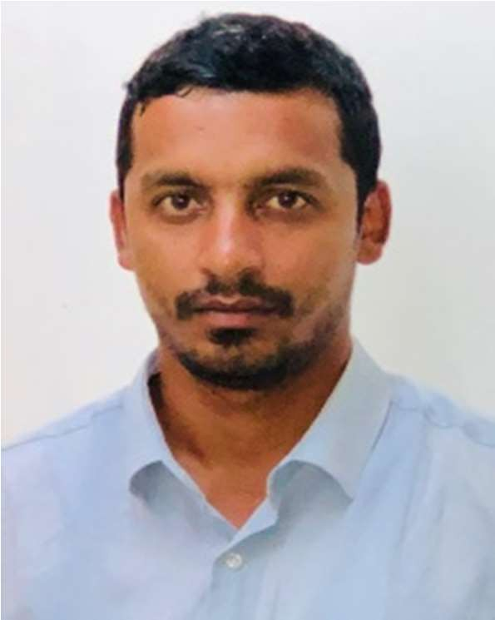
NANAIAH
Address: Dubai, UAE
Email: nanaiah-323737@2freemail.com

CIVIL ENGINEER

EXPERTISE PROFILE

Project Management Site Management Construction Management Resource Utilization
Budget Management Strategic Planning Execution & Analysis Quality Assurance Leadership Skills Health & Safety Communication Skills Team Management
- A results oriented and highly innovative professional with over 8 years of experience in project management, operations management, Site management, budget management, in the team management.
- Currently spearheading asa Project Engineer at AFRISE CONTRACTING LLC, DUBAI.
- Expertise in planning, designing and directing the construction and maintenance of civil works.
- In-depth knowledge and experience of Structural and Civil Codes and interpreting architectural drawings with knowledge in RMD, Doka, Formwork.
- Skilled in consistently completing the projects on time and within budget and Experience in site supervision, construction works, accountancy, tendering and evaluation.
- Outstanding ability of working independently with minimum supervision and
Committed to providing high quality service with a focus on health, safety and environmental issues.
- Effective communicator with the ability to communicate effectively with the
consultants, subcontractors, supervisors, planners, quantity surveyors and the general workforce involved in the project.

PERFORMANCE MILESTONES
  - Appreciation for Fast and Best Quality of work in High Rise Buildings and Villa Projects at Afrise Contracting LLC, & Kinetic Contracting LLC, Dubai.
  - Successfully completed Air Traffic Control (ATC) building in 25 days before the target date in Airport Project in Larsen & Toubro, Oman.
  - Awarded for maintaining Best Quality and Safety in the Airport Project at Larsen & Toubro, Oman.
  - Awarded for maintaining Zero Tolerance and 100% Safety at work at Larsen & Toubro, Oman.

PROFESSIONAL EXPERIENCE

CONTRACTING company in DUBAI SINCE JAN 2018 – PRESENT

Project: Town houses (10 No’s) & Luxury Villas at Dubai Hills Client: Zakaria Ibrahim Doleh, Anant Golyan. Role: Project Engineer
Project Cost: AED 28M

  - Analyzing the critical activities involved and finding remedial measures to solve problem, Mobilizing skilled workman, equipment’s, machineries and deploying various subcontractor for the project.
  - Planning and Execution of entire project activities and Coordinating with Client, Consultants.
  - Acquiring approvals from Dubai municipality, consultant and clients and follow ups

  - Conduct meeting with subcontractors like MEP, Facade, glazing, finishing subcontractor etc, for the effective results and resolve logistic problems prior to the requirements.
  - Follow HSE, HIRADC & zero tolerance in safety and maintain good quality at work by conducting trainings and close out plan gird issues
  - Prepare weekly and daily activity program as per schedule and maintain progress report and activity control sheet (ACS) of work
  - Conducting meeting with structural Engineers and consultants if there is a discrepancy in drawings or at site without hindering the work
  - Approvals and follows for Civil defense, Dubai police, Dubai Municipality, Building completion authority for the handing over to client

CONTRACTING company in DUBAI SINCE FEB 2016 –JAN 2018

Project: Al Saif Al Zahbi Properties, Sharjah Client: Saad Bin Hajji Bin Al Mutairi Project: Construction of Residential Buildings(G+8),Luxury Villas. Client: General Petroleum FZC. Role:Junior Project Engineer Project Cost: AED 60M
- Efficiently liaising with consultants, subcontractors, supervisors, planners, quantity surveyors and the general workforce involved in the project.
- Executing the work on site as per the method statement and specification as well as planning and scheduling
the work as per completion date.
- Mobilizing skilled workman, required equipment’s, machineries, deploying new agencies, analyzing the critical activities involved and remedial measures to solve problem.
- Effectively coordinating with HSE departments by conducting tool box meeting and following HIRADC & Maintaining 100% safety at work as well as with the QA/QC.
- Checking and arranging RMD & Doka Formwork shuttering materials Responsible for preparing Request for Inspection (RFI), acquiring approval from Consultant and Dubai Municipality approvals.

Construction company in MUSCAT, OMAN NOV 2011 – JAN 2014

Project: Salalah International Airport, Construction of Buraimi University B+G+6 Structure, Oman Client: Ministry of transport and communication, Directorate of safety and aviation service, University of Buraimi Steering Committee Role: Senior Civil Engineer Project Cost: US$765 M.
- Conducted inspection/testing the work of the subcontractors as per the relevant plans; ensured maintenance and signing off of quality records by the Project Manager/ Consultants/ Client.
- Efficiently monitored work progress as per the construction programs and submission of required site reports.
- Monitored, controlled, coordinated, and reported the works of different trade subcontractors and or trends for problems/ delays to Project Engineer/ Construction Manager/ Project Engineer.
- Maintained and recorded daily site activities and any circumstances with adverse effects on the project on to site management information system and Performa.
- Effectively prepare records of allocation of resources, labor rate analysis, and cost control.
- Reviewed drawings for correctness and clarity of information and performed necessary action to ensure availability of sufficient information.
- Ensured all tasks assigned individually and to the team collectively are completed as planned and on schedule.

Trading-Contracting company in MUSCAT, OMAN SEP 2010 – SEP 2011

Project: Construction of B+G+10 Residential & Offices Building, al Hail & Development of the coastal area for ROP, Muscat, Oman; Client: Royal Oman Police; Role: Site Engineer.
- Efficiently checked plans, drawings and quantities for accuracy of calculations and managed materials and human resources on site.
- Responsible for executing site works in the project while managing, monitoring and interpreting the contract design documents supplied by the client or architect.
- Effectively liaised with clients and their representatives (architects, engineers and surveyors), includingattending regular meetings to keep them informed of Progress.
- Maintained reports of consultant, sub-contractors for proper execution of the relevant scope on a daily basis
- Assisted in prioritizing work schedules and delegating assignments.
- Supervised all kind of masonry & superstructure works, plastering works, painting works, tile works etc.
Contracting company in MANGALORE, INDIA AUG 2009 – JUL 2010 Project: Admin building construction & Capsule lift construction in Data Centre (phase-1), Mangalore, India.
Client: ONGC-MRPL (Oil & Natural Gas Corporation of India - Mangalore Refinery & petrochemicals Limited)
- Responsible for managing day-to-day activities of the site, including supervising and monitoring the site labor force and the work of any subcontractors
- Performed labor allocation, prevention of wastage of man hours and materials, thereby completing the work within the prescribed time.
- Oversaw quality control and health and safety matters on site and prepared reports as required.
- Accurately prepared daily work progress report of the work done as per the schedule and submitted every week.
- Checked the daily labor output and took precautionary measures for the safety of the labors.

EDUCATION/ CERTIFICATIONS/ TECHNICAL SKILLS
- Bachelor of Engineering (Civil Engineering), Visveswaraya Technological University, Belgaum, India, 2009

- Technical Skills: MS Office Suite (Outlook, Excel,Word, PowerPoint), Win 7, Win 8, AutoCAD, Oracle Primavera P6.

Languages known: English, Hindi, Malayalam, Tamil and Kannada
Driving License: UAE References: Available on Request

