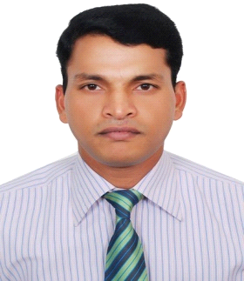
KHALID
Dubai U.A.E
Mobile # C/o 971505891826

Khalid.323909@2freemail.com

______________________________________________________________________

Career Objective

To secure a challenging position within a progressive company as per my qualification and experience in suitable field that can bring out my inherent abilities and contribute to the growth of my firm.

Current Job:

Organization : GOLDEN CITY L.L.C Dubai U.A.E
Designation : Sales Executive Cum Cashier
Duration : Seven years. (2008-2016)
Experience : Work experience in five star hotel (The Cove of Rotana,
Le Meridian, Anantara, Atlantis, Palm Jumeirah Dubai)
1. Activities Involved
- In charge of the gallery shop.
- Handling the process of sales related matter (|Cash /Card transaction)
- Give necessary instructions to the staff.
- Handling Stock level in Shop and arranging it in a systematic manner.
- Maintain inventory book / Monthly shop order
- Processing all online card transaction.
- Answer customer’s queries and provide necessary information on Return & Exchange procedures and policies accordingly.

From 2003 to 2008 – worked as Sales representative in India

Educational Qualification

Matriculation (S.L.C.) from Bihar Board Patna in 1999
Secondary (10+2) from Bihar Board Patna in 2001

Computer Skills

- One year certificate course in computer Application.
- Skilled in using computer for general purpose
- Good knowledge in MS Office
- Conversant with working on internet

Communicative Skills

Language | Speaking | Reading | Writing
English | Good | Good | Good
Urdu | Good | Good | Good
Hindi | Good | Good | Good

Personal Information

Gender | Male
Religion | Islam
Age | 33
Date of Birth | 20/04/1983
Nationality | Indian
Place of Issue | Patna
Visa status | Employment
Visa Expiry | One month notice.

Target Company

Description: a progressive company which has the best of standards in offering new and creative challenges and providing a platform for the further blossoming of my career.

Khalid

