Mohamed
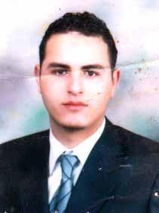
Date of Birth : 28 /10 / 1983
Nationality : Egyptian
Email: : mohammed.323930@2freemail.com

WORK EXPERIENCE
Pharmacist | With DHA ELIGIBILITY | LETTER
Pharmacist | -El-Hakeim Pharmacy . | 2/4/2007 to 1 / 1 / 2010
Senior Pharmacitst | - El-Nada Hospital . | 1/ 2 / 2010 to 1 / 9 / 2016

EDUCATION/DEGREES

Bachelor Of Pharmacy – Misr University for Science and Technology |  |  |  | 2007 |  | Good
 |  |  |  |  |  | GBA :2.3
TRAINING COURSES
-Selling Skills Course – El-Hikma Center.
-Communication Skills – El-Hikma Center.
-Negotiation Skills – El-Hikma Center.
-Advanced Selling Skills – El-Hikma Center.
-Coaching Course – Right Care Pharma.
SKILLS
 |  | Computer Skills
• |  | Internet
• |  | Windows
• |  | Office

Personal Skills

- Able to work under stress (internal & external)
- Specifying & Analyzing problems and find solutions

- Able to work alone or in a group in order of achieving goals

- Great with computer & Internet
- Able to work for a long and continues hours.

LANGUAGES KNOWLEDGE

Arabic : Mother Tongue

English : Fluent

