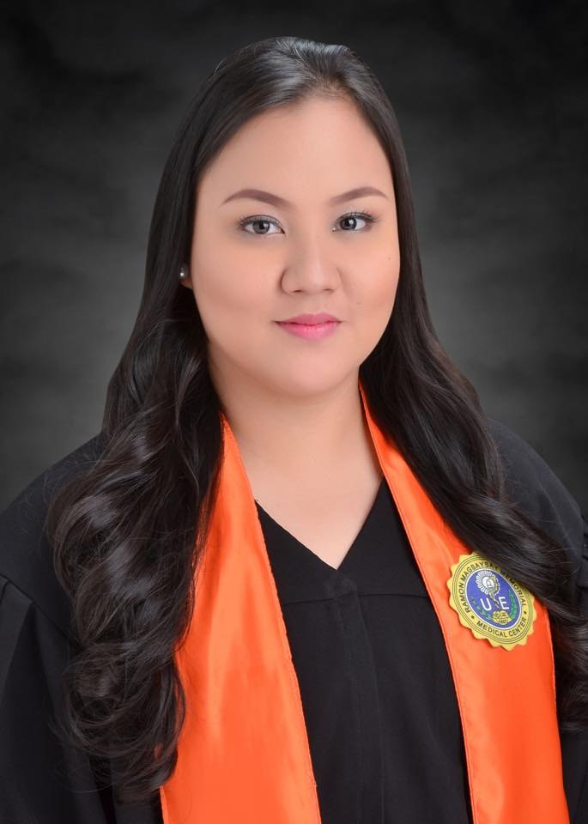
CV No 1943676

Debby Grace, RN
Position Applied for : Receptionist

CAREER OBJECTIVES:

- To work in this companyl with such perseverance and enthusiasm.
- To apply my knowledge and skill with hard work and persistency.
- To discover and acquire new knowledge and experiences that will contribute to the enhancement of my skills and character.
- To have a contribution for the betterment and growth of this company.

PERSONAL AND TECHNICAL SKILLS:

- Good in speaking and writing English & Filipino language.
- Literate in Microsoft Office.
- Highly organized and efficient.
- Quick to adapt in certain situations.
- Fast learner
- Problem analysis and problem solving.
- High level of intrapersonal skills.
- Good time management skills.
- Ability to work with people from different cultures and socioeconomic backgrounds.
- Analyze information and make crucial and life-or-death decisions requires keen critical thinking skills.
- Accommodating to all clients.

PERSONAL INFORMATION:

Date of birth: March 22, 1995
Age: 20 years old
Birth Place: Manila City
Civil Status: Single
Sex: Female
Weight: 90 kg
Height: 153 cm
Religion: Roman Catholic

EDUCATIONAL ATTAINMENTS:

Tertiary

University of the East Ramon Magsaysay Memorial Medical Center
# 64 Aurora Boulevard, Barangay Doña Imelda, Quezon City
Bachelor of Science in Nursing
2011 up to 2015

Secondary
Good Shepherd Christian School
71 I Lopez Street, Mandaluyong City
2007 up to 2011

Primary
Good Shepherd Christian School
71 I Lopez Street, Mandaluyong City
2004 up to 2007

Dominican School
1044 Lacson St, Brgy 479 -Z-47, Manila, 1008 Metro Manila, Philippines

2001-2003

SEMINARS ATTENDED:

- 2011 – Clinical Management in Nursing Informatics
- 2013 – Current Advances and Nursing Responsibilities in Stem Cell Harvesting
- 2012 – ABCs of Lactation Nursing Management Seminar
- 2014 – NLE Framework: Success through Testmanship
- 2015 – Succession Planning in Nursing
- 2015 – Challenges of Globalization in Nursing Practice
- 2015- ICLDC Education: Diabetes and Endocrine Update

ACHIVEMENTS AND CERTIFICATIONS:

- 2012 – Completion of NSTP 1 and NSTP 2
- 2012 – Completion of the WHO Partograph E-learning Course
- 2015 – Philippine Nursing Licensure Examination board passer under the Professional Regulation Commission

Debby Grace C. Albano – CV No 1943676

To interview this candidate, please send your company name, vacancy and salary offered details along with this or other CV Reference Numbers that you may have short listed from
http://www.gulfjobseeker.com/employer/cvdatabasepaid.php
addressing to HR Consultant on cvcontacts@gulfjobseekers.com

We will contact the candidates to ensure their availability for your vacancy and send you our service HR Consulting Fees quotation for your approval. Whatsapp +971504753686

______________________________________

