CV No 1944306

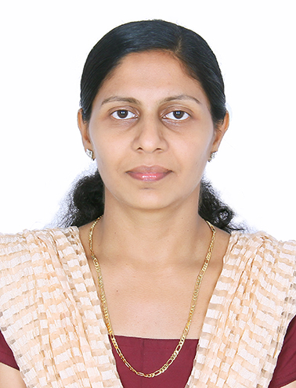
ANU MOL SINUTHOMAS
HAAD-RN
AGN-No: AGN-156159

Visa Status
Visit Visa

Nationality : Indian
Date of birth : 12/05/1982
Gender : Female
Marital status : Married
Husband Name: Sinu Thomas
Religion : Christian

Languages Known
English, Malayalam, Hindi, & Kannada

C U R R I C U L U M V I T A E
OBJECTIVE:
To be able to obtain a position that will enable me to apply knowledge and practice my skills in fields of NURSING and to able to engage in fulfilling work that will enable me to develop and grow in the Nursing profession be being exposed to an environmental that ensure continuous learning and developing.

SKILLS:
Experience as a registered nurse at,
NICU & Medical / Surgical Ward.
WORK EXPERIENCE SUMMARY.
[More than 6 years]
- Duration : 2 Year 5 Months
- Designation : Registered Nurse
- Working Section : NICU & Medical . Surgical Ward
- PG MEDICAL TRUST HOSPITAL
NILAMBUR MALAPURAM KERALA INDIA.
- Duration : 2 Year 3 Months
- Designation : Registered Nurse
- Working Section : NICU & Medical
Surgical Ward.
- KARUNA HOSPITAL, MUMBAI INDIA.
- Duration : 1 year 5 Months
- Designation : Registered Nurse
- Working section : Medical surgical Ward

Professional qualifications
Course Institution Year of passout
- Diploma in general nursing &
Midwifery (3 1/2 year) : Masood School of nursing
Mangalore Karnataka 2009
Educational Qualification
- B.com. : University of Calicut 2003
- Pre- Degree : University of Calicut 1999
- SSLC : State Board of Public Examination 1997
Certification course
- ACLS, BLS & ECG : American Heart Association

Duties performed.
- NICU Care
- Neonatal care
- IV Cannulation and Medication
- ECG Monitoring
- Tracheostomy care
- Diagnostic Assessment
- IM Medications
- Assisted in LP procedure
- Blood transfusion
- Care of patients with different surgeries like abdominal, ENT, Ortho, Head ..etc..
- Writing Nursing Care plans and maintenance of patients records
- Maintaining intake output chart Collection of specimens
- Nasogastric Tube insertion
- Assisted in Suturing
- Assisted in Plaster of Paris application and care of plaster of Paris
- Foley's Catheterization
- Assisted in Bronchoscopy
- Monitoring vitals

Place of Registration
Registered Nurse Registration no Year of registration

- Karnataka state Nursing Council 05DN15076 13th may 2009
- Kerala nurses and midwives council 72945 15th November 2011

DECLARATION
I hereby declare that all the statements given here are true and correct to the best of my knowledge and belief.
Yours faithfully
Anumol SinuThomas

ANU MOL SINUTHOMAS – CV No 1944306

To arrange interview with me, please send your company name, vacancy and salary details to my HR Consultant cvcontacts@gulfjobseekers.com Whatsapp +971504753686

______________________________________

