CV No 1944486
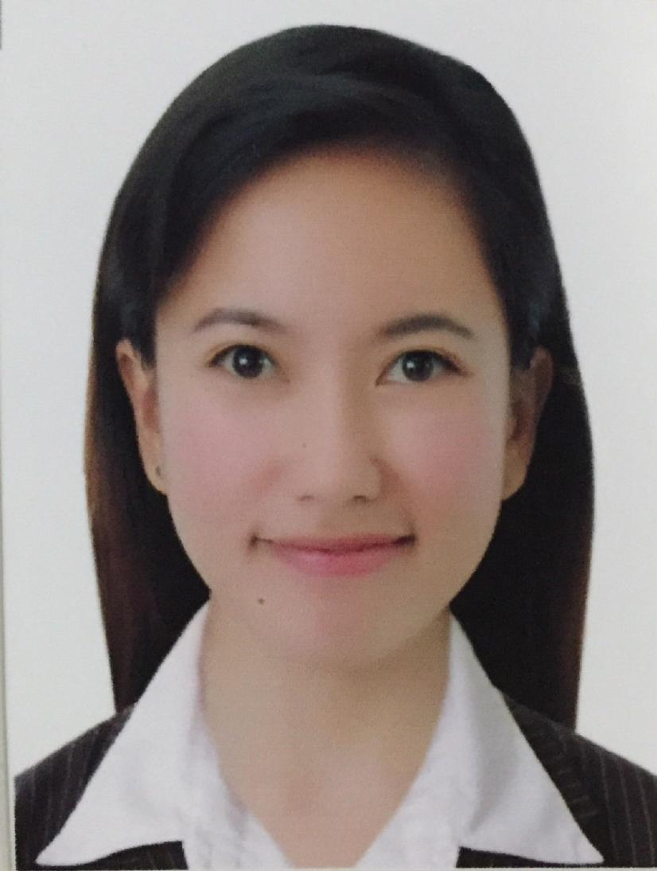
MARIE JOCELYN

POSITION APPLIED FOR: STAFF NURSE

PERSONAL BACKGROUND

Height:5 ft.. Weight:45 kgs
Birth Date: December 24, 1985
Place of birth: San Carlos City Pangasinan, Philippines
Age: 30 years old
Nationality: Filipino
Religion: Born Again Christian
Civil Status: Single

JOB SUMMARY
- Assess patient’s condition and needs.
- Assist the doctor and carries out prescribe treatment including administration of medicine.
- Performs procedures accurately, completely and safety according to hospital policy.
- Able to function quickly and effectively in an emergency situation.
- Collaborates with others health care team members in planning and providing safe and comprehensive care.
- Maintains safe and clean environment.
- Evaluates patient’s treatment and care.
- Report pertinent information to appropriate nursing medical personnel.

EDUCATIONAL BACKGROUND

2003-2007 VIRGEN MILAGROSA UNIVERSITY FOUNDATION
TERTIARY SAN CARLOS CITY, PANGASINAN, PHILIPPINES
Bachelor of Science in Nursing

1998-2002 CLARK EDUCATIONAL CENTER
SECONDARY PNR SITE, San Carlos CITY, PANGASINAN, Philippines

1992-1998 CENTRAL II ELEMENTARY SCHOOL
PRIMARY SAN CARLOS CITY PANGASINAN,PHILIPPINES

WORK EXPERIENCE(5years and 9 months)

August 2014 – August 2016
Staff Nurse - Emergency Room

DUTIES AND RESPONSIBILITIES
- Performs triage, while considering both physical and psychosocial elements.
- Manages basic life support needs and stabilizes patients until attending physician is available, based upon nursing standards and protocols.
- Works directly under physicians, assisting them during examinations, diagnostic testing and treatments.
- Provides intravenous therapy, cleans and bandages wounds, and basic bedside care.
- Provides total quality patient care as well as transcultural principles into nursing care.
- Sustain safe and therapeutic environment to patients.
- Participates in monitoring of the planning, delivery of care and evaluation of the individual patient care.
- Upholds positive professional interpersonal relationship with patient and their families, co-workers and other members of the health care team.

November 2010-June 2014
Staff Nurse - Medical Surgical Ward
Specialists Group Hospital and Trauma Center
Tapuac District, Dagupan City, Philippines

DUTIES AND RESPONSIBILITIES
- Assess individual patient needs for nursing.
- Assist the patient in indentifying her/his needs for medical assistance, self-help and rehabilitation.
- Observe symptoms and reaction including symptomatology or physical and mental condition.
- Plan nursing care appropriate for the patient involving her/his patient family and nursing assistance.
- Join the family health team, the physician other nurses, special workers, nutritionist, medical technician and other professional workers in developing the total care plan for the patient.
- Execute orders of the physician concerning treatment and medication.
- Record any report fact about patient including evaluation of the whole cases.

PROFESSIONAL EXAMINATION TAKEN

HAAD (HEALTH AUTHORITY ABU DHABI) – PASSED
EXAM DATE :August 26, 2016

SAUDI COMMISION FOR HEALTH SPICIALTIES

NURSE TECHNICIAN 15-T-N-0001061

VALID UNTIL: JANUARY 2018

PROFESSIONAL REGULATION COMMISSION

LICENSE NUMBER:0652423

VALID UNTIL:DECEMBER 24,2019

TRAININGS/SEMINARS ATTENDED

BASIC LIFE SUPPORT: CARDIOPULMONARY RESUSCITATION
Saudi Heart Association
AL HADA ARMED FORCES HOSPITAL - TAIF REGION
Taif, Kingdom of Saudi Arabia
November 26, 2014

EMERGENCY SEVERITY INDEX
AL HADA ARMED FORCES HOSPITAL - TAIF REGION
Taif, Kingdom of Saudi Arabia
APRIL 05, 2015

INFECTION CONTROL POLICIES
AL HADA ARMED FORCES HOSPITAL - TAIF REGION
Taif, Kingdom of Saudi Arabia
JULY 30, 2015

PHLEBOTOMY WORKSHOP FOR NURSES
PRINCE MANSOUR HOSPITAL-TAIGF REGION
Taif , Kingdom of Saudi Arabia
DECEMBER 22, 2015

CONSCIOUS SEDATION
PRINCE SULTAN MILITARY HOSPITAL-TAIF REGION
Taif , Kingdom of Saudi Arabia
January 25, 2016

SKILLS
- Active in general patient care
- Can work with minimal supervision
MARIE JOCELYN S. REYES – CV No 1944486
Whatsapp +971504753686
To interview this candidate, please send your company name, vacancy, and salary offered details along with this or other CV Reference Numbers that you may have short listed from http://www.gulfjobseeker.com/employer/cvdatabasepaid.php
addressing to HR Consultant on email: cvcontacts@gulfjobseekers.com
We will contact the candidate first to ensure their availability for your job
and send you the quotation for our HR Consulting Fees.
- Have good oral and written communication skills
- Hard working and a fast learner
- Proven record of reliability and responsibility
- Relate well to people from a variety of cultures
- Fluent in English
- Computer literate

