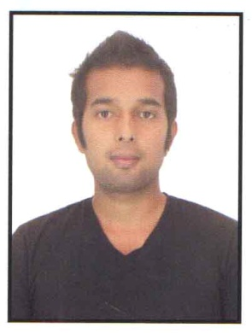
CV No 1944564
DEEPAK

OBJECTIVE:- Seek to work in an environment that will challenge my retail trade experience further, while
allowing me to contribute to the continued growth and success of the organization.
EXPERIENCE:-
08 AUGUST 2012-13 FEB 2016
- Head Cashier
- Retail Sq Ft of Store- 23000 sq ft.

ROLES & RESPONSIBLITIES:
- Reporting to the store manager
- Discussing daily target and focusing customer service
- Resolve customer question and enquiries
- Responsible for managing staff shift works
- Monitor customer service work performance
- Give explanation about new product provide descriptions pamphlet
- Driving the loyalty programme of landmark group WLL ( Customer Membership Card)
- Monitored sale activities to ensure that customer receive satisfactory service and quality goods
- Created positive atmosphere by smiling, greeting and providing pleasant, friendly experience
- Directed cashiers engaged in reconciling cash receipt, returns/exchange, closing procedure and in performing service for customers
- Maintain and improved store security and safety concerns

LOUIS PHILIPPE (MADHURA FASHION) (06 Feb 2012-20 Jul 2012)
Sales Associate, Delhi India
ROLES & RESPONSIBLITIES:
- Reporting to the manager
- Doing customer service and achieving sales target
- Visual Merchandising and stock replacement
- Making customer membership cards

ACADEMIC QUALIFICATION
- Completed Bachelor of Arts from Manipur University in 2013
- Completed Higher secondary in 2010

PROFESSIONAL QUALIFICATION
Microsoft word, excel, PowerPoint
EXTRA CURRICULER ACTIVITIES:
- Employee of the month ( March & June 2013, Landmark Group)
- Customer Membership card highest achievement for the month of Aug 2014

Personal Details:
- Fathers Name- Gangaram Timsina
- Date of Birth- 20/03/1993
- Marital Status- Single
- Languages Known- English, Hindi & Arabic (Elementary)
TOURIST VISA EXPIRES ON 28th OF FEBRUARY 2017

Date: Deepak Timsina
DEEPAK TIMSINA – CV No 1944564
Whatsapp +971504753686
To interview this candidate, please send your company name, vacancy, and salary offered details along with this or other CV Reference Numbers that you may have short listed from http://www.gulfjobseeker.com/employer/cvdatabasepaid.php
addressing to HR Consultant on email: cvcontacts@gulfjobseekers.com
We will contact the candidate first to ensure their availability for your job
and send you the quotation for our HR Consulting Fees.

