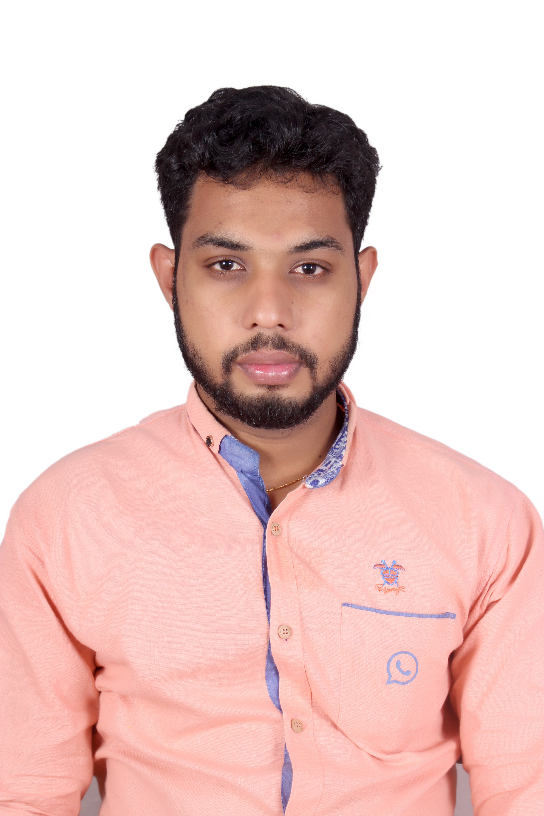
CURRICULUM VITAE

RIJO
RIJO.324132@2freemail.com

POST APPLIED FOR : REGISTERED NURSE
TOTAL EXPERIENCE : 3 YEARS 9 MONTH

CAREER OBJECTIVE:
To secure full time position as a registered nurse with focus on critical care nursing in intensive care units. Organized and detail oriented with high standards for performance and maintenance of treatment protocols. Patient-focused and compassionate care giver.

LICENCES AND CERTIFICATES.
DHA- RN Exam Passed
Registered Nurse in India ACLS (From 15/6/2015 to 15/6/2017)
BLS (From 15/6/2015 to 15/6/2017 )

EDUCATIONAL QUALIFICAITON.
Qualification | Institute | Year | Remarks
BSC NURSING | LEELA COLLEGE OF NURSING | 2006-2011 |  | I year - 57  II year - 57  III year - 56  IV year - 51
EMPLOYMENT HISTORY.
- Working as an Intensive Care Unit Registered Nurse in PEDIATRIC & ADULT CTVS ICU at SEVEN HILLS Multi Super Specialty Hospital with 1500 Bedded (JCI, NABH,NABL & AHA Accredited) with advanced equipments in Mumbai, Maharashtra, India from 20 th November 2012 to 5 th December 2015
- Working As An Intensive Care Unit Registered Nurse In Mangala Multy Speciality Hospital With 250 Bedded Manglore,Karnataka,India From 10 th December 2015 To 22 nd September 2016
PROFESSIONAL EXPERIANCE
- Worked as part of interdisciplinary team caring for critically ill patients in ICU.
- Observed, assessed and documented patients’ vital science
- Helped patients with basic care, changed bedding and served meals
- Administer medications and intravenous fluids
- Monitor telemetry ad respond to calls ad emergency life saving situations
- Assisted physicians with procedures and protocols
- Educate patients and families and caring support
- Groom and bath patients and provide assistance with general care
- Documentation. Resuscitating during cardiac and respiratory arrest. Taking hand over and report from previous shifts, Nurses bedside rounds and attending doctors rounds, Family advice, counseling and support patients and relatives
- Computer charting, Infection control, Death care

SEMINARS ATTENDED
- ACLS, BLS, – At Seven Hills Hospital,

ASSISTED IN.
Endo tracheal intubations , central line insertion, Blood culture, Insertion and removal of chest tube, Pleural aspiration, Bladder catheterization, CPR, Abdominal tapping, Suture removal, Inter costal drainage, Arterial line insertion, dialysis catheter insertion, IABP insertion,

TYPES OF CASES.
CABG, Mitral valve repairs and replacement, intra cardiac repair, ALCAPA,SWITCH,ASD closure, VSD closure, PDA ligation, AP window repair, TOF, Coarcation of aorta, right ventricular out flow tract, bidirectional glen shunt, fontan, sennings operation, double valve repair, mitral value repair,atrio ventricular repair, atrio ventricular canal defect, BT shunt.

EQUIPMENTS FAMILIAR.
Ventilators(Nellcor Puritan Bennett 840, Hamilton, Schiller), Infusion Pumps, Syringe Pumps, Glucometer, Nebulizer, Suction Apparatus, Laryngoscope, Defibrillator, ECG Machine, Steam Inhaler, Humidifier, Chest Tube Drainage System, Pulse Oxymeter, Cardiac Monitor, Sphygmomanometer, Bipap Machine, IABP Machine, ABG Machine, ACT Machine, Pressure Infuser, CCO Monitor, Pace Maker, Haemotherm, Bairhugger.

PERSONAL DETAILS
Sex : Male
Date of Birth : 04-11-1988
Nationality : Indian
Marital status : Single
Languages known : English, Hindi, Malayalam

DECLARATION

I hereby declare that the above mentioned details are true and correct to the best of my knowledge and belief. I shall carry out all my duties and responsibilities assigned to me up to the entire satisfaction of my superiors and company.

