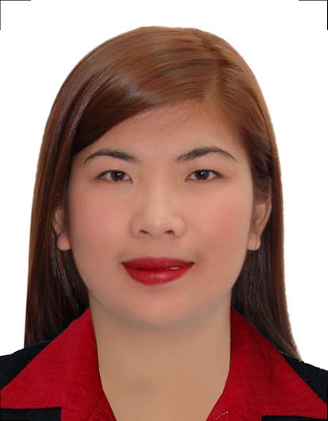
SARAH
SARAH.324142@2freemail.com

AIMS & OBJECTIVES

To find a challenging position to meet my competencies, skills and education. I am
enthusiastic and adapt very quickly in any environment. I am a fast learner and always strive to be a team player to grow personally and professionally. I relate well to people of all age groups and cultures and I am eager to further my career where there is opportunity for growth.

WORKING EXPERIENCE:

EHS LENS PHILIPPINES, INC.
General Affairs Staff, Administrator
Batangas, Phillipines
May 2, 2016- June 30, 2016

OPTIMAL LABORATORIES, INC.
Laboratory Encoder
Lipa City, Phillipines
September 23, 2015- January 15, 2016

TAIHAN PRECISION TECHNOLOGY (PHILS.)CO., INC.
General Affairs - Purchasing Staff, Administrator
Batangas, Phillipines
December 3, 2014 – May 15, 2015

HELPING HAND DEVELOPMENT COOPERATIVE
Membership Affairs - HR Recruitment Staff Administrator
Batangas, Phillipines
May 12, 2014 – October 13, 2014
CRESTEC PHILIPPINES
Office Staff - Administrator
Laguna, Philippines
January 28, 2014 – May 7, 2014

STAR APPLIANCE CENTER, INC.
Counter Assistant
Lipa City, Phillipines
November 2012 – April 2013

SEMINARS / TRAININGSATTENDED

The 3rd Strategic Recruitment and Talent Selection Summit
The Pan Pacific Hotel
Malate, Manila, Philippines
May 29- 30, 2014

ON THE JOB TRAINING

-Industrial Setting
PLDT – Batangas
Batangas City, Phillipines
March – May 2012

-Clinical Setting
Cavite Center for Mental Health
TreceMartires, Cavite, Phillipines
November 2011 – February 2012

Understanding the Process of Psychological Assessment: Basic Interviewing,
Test Interpretation and Report Writing Skills
Cavite Center for Mental Health
TreceMartires, Cavite, Phillipines
December 8, 2011

3rd ICCS International Program on Psychological Communication
University of the Philippines
Diliman, Quezon City, Phillipines
February 26, 2011

Psychotherapy with Essentials of Assessment and Evaluation of Personality
Cavite Center for Mental Health
TreceMartires, Cavite, Phillipines
January 28, 2011

AFFILIATIONS

Member
2008 – 2012
Alliance of Future Psychologists
Batangas State University – JPLPC Campus
Malvar, Batangas, Phillipines

EDUCATIONAL BACKGROUND

Tertiary: BATANGAS STATE UNIVERSITY–Malvar Campus
Poblacion, Malvar ,Batangas
Bachelor of Science in Psychology
Malvar, Batangas, Phillipines

Secondary: Anilao National High School
Anilao, Lipa City, Batangas, Phillipines
Class of 2008
Achiever

Primary: Pagolingin Elementary School
Pagolingin East, Lipa City, Phillipines
Class of 2004

