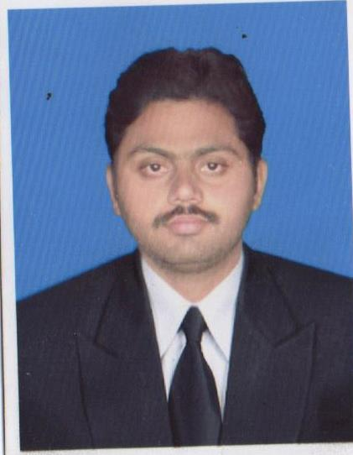
Yasar

CARRIER OBJECTIVE
To explore untapped opportunities for fulfillment of growth and intellectual needs and equally keep my carrier dynamic and motivated. Seeking to get a career oriented job in a professional environment that offers utilization of my skills and provide learning opportunities to keep pace with advanced techniques.
PERSONAL PROFILE

- Father’s Name : Sarfraz
- Date of Birth : 15/03/1990
- Nationality : Pakistani
- Religion : Islam
- Marital Status : Single
- N.I.C No : 33303-7816240-3
- Domicile : Toba Tek Singh (Punjab)
ACADEMICQUALIFICATIONS
- M.B.A/MS 2015 NCBA&E Lahore.
- B.com 2010 PUNJAB University Lahore
- F.A 2008 B.I.S.E. Lahore.
- Matric (science) 2006 B.I.S.E. Lahore.
PROFESSIONAL QUALIFICATIONS ____
- I have done I year diploma in office management and computer application.
COMPUTER SKILLS
Use of Basic Computer, Typing Utility (Urdu, English Typing) Microsoft Power Point, Microsoft Excel, Microsoft Word,
In-Page Processor, Urdu Word Online Systems, photo Scape,
Installation &Trouble Shooting …………….
EXPERIENCE
- 2 year experience in Masood Textile Mill as Computer Operator 15/10/2009 to 1/10/2011.
- 1 year experience in Chenab mill as a purchaser officer &accessories store incharge 8/11/2012 to 5/6/2013.
- 2 year experience as a officer in procurement deptt 01/07/2013 to 01/08/2015.
REFERENCE
Reference will be provided on demand.

Yasar Sarfraz – CV No 1945014

To interview this candidate, please send your company name, vacancy and salary offered details along with this or other CV Reference Numbers that you may have short listed from
http://www.gulfjobseeker.com/employer/cvdatabasepaid.php
addressing to HR Consultant on cvcontacts@gulfjobseekers.com

We will contact the candidates to ensure their availability for your vacancy and send you our service HR Consulting Fees quotation for your approval. Whatsapp +971504753686

______________________________________

