CV No 1945200
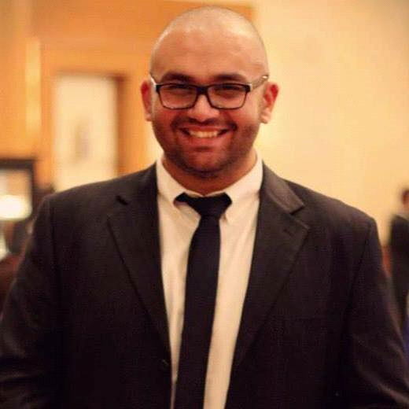 Mohamed
Birthdate: 26 August 1991
Status: Single
Nationality: Egyptian
Personal statement
I am a Dental School Graduate with persistent deep passion for sales and marketing by heredity, with above average sales presentation skills, introducing and detailing products, providing services in parallel with physicians and nursing staff, firm assessment abilities with a gifted perception of customer needs and the ability to convince and recommend effective solutions depending on the situation variability, very quick learner, highly motivated, enthusiastic, and deeply committed to professional excellence in sales field.
Educational Experience:
- Al Wadi British School graduate IGCSE, Jeddah, Saudi Arabia 2008.
- Bachelor degree (BDS) in oral and dental medicine from Misr international university in Cairo, Egypt Jun. 2014.
Experience:
- Internship as Sales representative with Arabian Trading Supplies Jeddah, Saudi Arabia Jan-May 2011.
- Worked as a sales executive for Elbasma dental supplies store in Qasr einy street, Cairo, Egypt Sep- March 2012-2013.
- Attended UAE International Dental Conference (AEEDC) to review latest advancements in dental materials, instruments and techniques and added extensive dental supplier’s knowledge in the UAE Feb. 2015.
- Attended UAE Gulf food Expo for FMCG in Dubai, 2016.
- Participated in Disease awareness campaigns in Cairo, Alexandria, and Fayoum regions promoting infection control in rural areas. Egypt 2016.

- Attended Medical conference and seminar regarding promoting patient safety procedures, usage and application of latest advancements in Medical and dental technologies, equipment and materials in HKU, Hong Kong 2016.
- Attended various Summit meetings and conferences on Marketing and sales of Dental materials and equipment in Russia and Siberian region in Sechenov Moscow state medical University, Moscow 2016.
- Completed 2 years of Experience in a private clinic, part time dentist, full time management of purchases and patient records, flow of dental material usage and replacement, advertisement, monitoring competition and analyzing competitor activity, gathering up-to-date lists of dental suppliers with their latest prices due to economic fluctuations and managing to get the most beneficial deals possible Aug. 2014 to date.
- Participated in various charity educational campaigns in poor villages and orphanage schools promoting importance of Pharmaceutical and Dental healthcare products 2014-2015.
Skills:

- Strong communication skills, together with problem solving and organization skills.
- Ability to work successfully under pressure both independently and within a team.
- Proficient Computing skills: Excellent knowledge with MS Word, MS PowerPoint, intermediate MS Excel skills.
- Language skills: Fluency in English and Arabic, and beginner Russian.
Hobbies:
- Basketball, Reading, Tech savvy, software implementation, computer hardware repairing.
Driving Licenses:
- Valid KSA GCC driving license.
- Valid Egyptian Driving License.

Mohamed Khaled Abdeldayem – CV No 1945200

To interview this candidate, please send your company name, vacancy and salary offered details along with this or other CV Reference Numbers that you may have short listed from
http://www.gulfjobseeker.com/employer/cvdatabasepaid.php
addressing to HR Consultant on cvcontacts@gulfjobseekers.com

We will contact the candidates to ensure their availability for your vacancy and send you our service HR Consulting Fees quotation for your approval. Whatsapp +971504753686

______________________________________

